NEWSLETTER: SEPTEMBER 7th 2026

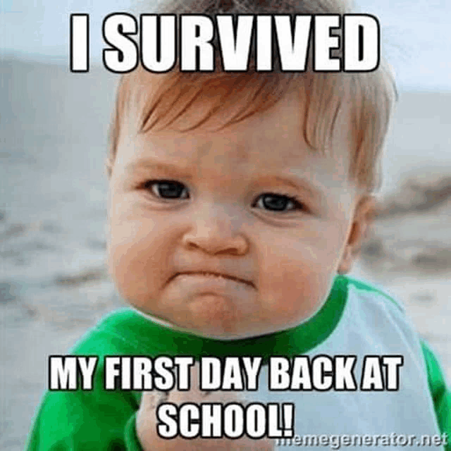
Welcome Back!

A very warm welcome back to all our children and families, and a special welcome to those who are joining the Irlam Primary School family for the very first time. It has been wonderful to see everyone return with such enthusiasm and positivity.
Our new EYFS children are settling in beautifully. There were a few tears on the first day, which is only natural, but by 9.15am on day two they were all smiling, having fun and already beginning to feel at home! The rest of our children have been absolutely fabulous too, enjoying time with their new teachers, catching up with friends and making new ones.
Thank you for sending the children back looking so smart in their uniforms. They are a credit to you all. Just a quick reminder that children should wear black school shoes and jewellery should not be worn in school, with the exception of watches.
Let's make this year our best year yet!

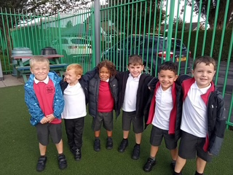
Photographs and Class Dojo
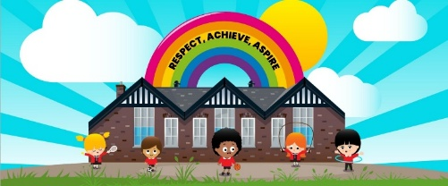
We keep an up-to-date list of all children who are not permitted to have their photograph taken. However, if you would like to receive photographs of your own child through Class Dojo, where they can only be viewed by you and not by other families, please contact school. This is something we can arrange individually and is a great way to share special moments from your child's school day

Class Newsletters and Our Website
All of our class newsletters are available to read on the school website. A link will be sent to you which will take you directly to the relevant page.
While you're there, why not have a look around? Our website contains a wealth of information about school life, our curriculum, key policies, events, support services and much more. It is often the quickest way to find the information you need.

Safeguarding at Irlam Primary School
Safeguarding is our highest priority, and ensuring that every child is safe, happy and supported is at the heart of everything we do. If you ever have any concerns about a child, please do not hesitate to contact us.
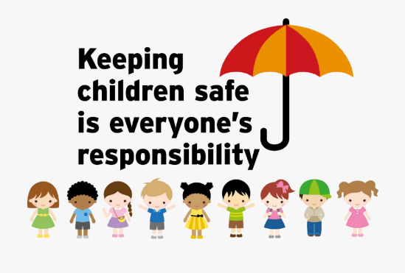
Designated Safeguarding Lead (DSL):
Elaine Darwin, Headteacher
Deputy Designated Safeguarding Leads (DDSLs):
Lindsey Caplan, Deputy Headteacher
Amanda Power, Inclusion Lead
Safeguarding Team:
Joanne Higham, School Business Manager
Lisa Freer, Assistant Headteacher
Anne MacKenzie, Learning Mentor
Clare Rollings, School Office
The school uses a secure online safeguarding platform called CPOMS to record and manage safeguarding concerns. We have robust safeguarding procedures in place, which all staff follow consistently.
Every member of staff at Irlam Primary School receives training in Safeguarding, Keeping Children Safe in Education (KCSIE) 2026, Cyber Security, GDPR, Prevent, WRAP, Fire Safety, and Allergy and Anaphylaxis Awareness.

PARKING
We have received complaints already from local residents regarding dangerous and inconsiderate parking around the school. Please do not block driveways, park on corners, or stop in locations that obstruct visibility for pedestrians and road users. Most importantly, these behaviours put our children and families at significant risk during busy drop off and pick up times. Where possible, please use the Lidl or Tesco car parks and walk the short distance to school. We are currently exploring the introduction of a Street Safe scheme, which would restrict parking to permit holders and utilise camera monitoring during school start and finish times. In the meantime, we ask all parents and carers to park safely, legally and respectfully so that we can keep our children and the local community safe.

Working Together

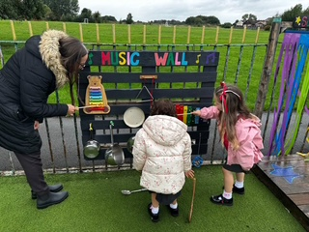
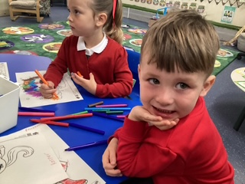
As many of you know, I have an open-door policy. We want our children and families to be happy, to flourish, and to feel that they truly belong at Irlam Primary School.
We are a fully inclusive school where every child matters. Our staff work tirelessly to ensure that all children receive a fabulous education while feeling safe, valued and happy every day.
If you ever have a concern, question or issue, please come and speak to us. We can usually resolve things quickly when we work together. Please don't rely on playground gossip or social media rumours, as these are often inaccurate. If something is worrying you, let's have a conversation about it.

Mrs Darwin’s ‘Thought for the Weekend’
Our collective worship theme this week has been New Beginnings.
As we start a brand new school year, remember that every day is an opportunity for a fresh start, a new friendship, a new challenge, or a new success. Sometimes the smallest step in a new direction can be the beginning of something wonderful
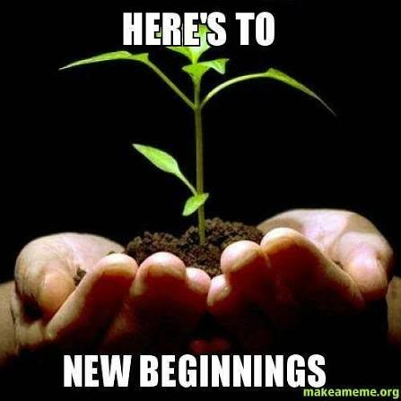
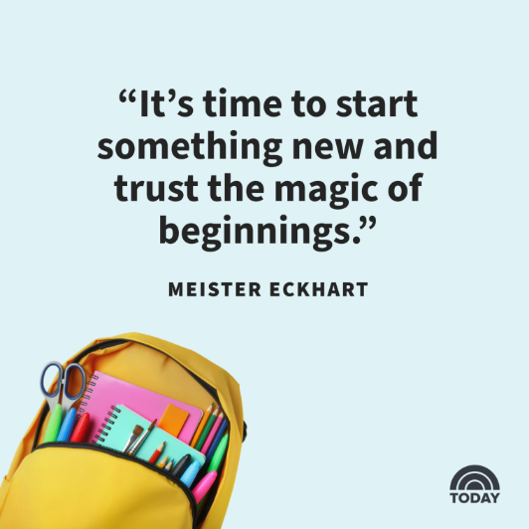

Have a fantastic weekend, everyone!
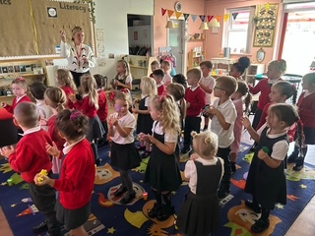
Mrs Darwin
Headteacher 🌟
