What a wonderful summer term we have had, what a wonderful year! The pupils have completed a variety of learning and personal development activities and thrived. We have been celebrating all the pupils’ achievements and success this year – there have been so many! Have a lovely summer,

Mr Caldwell (HT)

Summer Term
Beehive

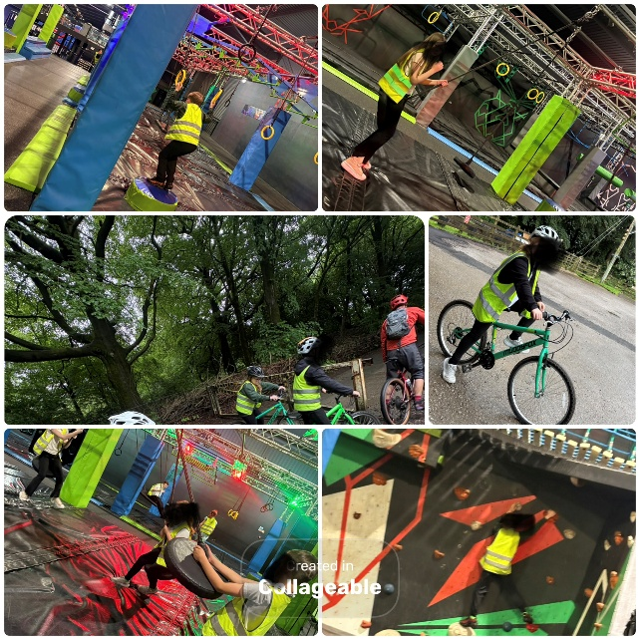
What a fantastic summer term we've had!
We've loved starting mountain biking as part of our personal development programme, enjoyed our weekly visits to Total Ninja, and made the most of the sunny weather at Alderbrook with picnics, water fights, and plenty of ice lollies.

Our treat trip to Heaton Park was a highlight, where we paddled our boats on the lake and had lots of fun together.

Back in class, we've been busy baking, making slime, and sharing lots of laughter. It's been a wonderful term, and we wish everyone a happy and relaxing summer break.

Next term, our exciting topic is Frozen Kingdom—the perfect theme for autumn! We'll discover the fascinating story of the Titanic and learn about the amazing animals that live in the Arctic and Antarctica.
In English, we'll write informative reports about the Titanic and create winter-inspired poetry. To bring our learning to life, we'll visit the Titanic Museum, meet polar animals at Blackpool Zoo, and experience freezing temperatures during a trip to Chill Factore... Brrrr!
It's going to be a fun-filled term packed with exciting experiences, hands-on learning, and unforgettable adventures. We can't wait to begin our Frozen Kingdom journey!

- Titanic Museum – Week beginning 07.09.2026
- Blackpool Zoo – Week beginning 05.10.2026
- Pumpkin picking – Week beginning 19.10.2026
- Chill Factore – Week beginning 14.12.2026
- Family morning – Meet the team 25.09.2026
- Family morning – Friday 11th December 2026

