- Family morning – Friday 25th September 2026
- Family morning – Friday 11th December 2026
- Messy Mixtures Morning- TBC
- Salford Museum and Art Gallery- TBC
- Afternoon Tea Party- TBC

In Autumn 1 we will be looking at the theme Mess, Muck and Mixtures and in Autumn 2 our theme will be Bright Lights, Big Cities. We will be reading a range of fiction and non-fiction books, which will provide a stimulus for writing. In PSHE, the children will be looking at relationships. In Maths, throughout Autumn term, we will be covering a range of topics including place value, addition, subtraction and shape. Science will be looking at animals including humans, and Geography will look at local area including the UK. History will be based on big events in History, and Art will be looking at colour and collaging! In DT we will look at food and then joining and structures to round it off. We will have a messy mixtures morning, and an afternoon tea party and museum trip.
Willow Tree Class has had a fantastic Summer Term packed with fun learning and exciting experiences. The children enjoyed personal development opportunities at Projekts, swimming and soft play, in class we have explored our Land Ahoy! topic, learning about pirates and water safety with the RNLI. In English we have been solving clues through the story of Steven Seagull – Action Hero. Maths, they worked hard on time, shapes and fractions, and to celebrate a successful term we finished with a wonderful trip to New Brighton Beach.
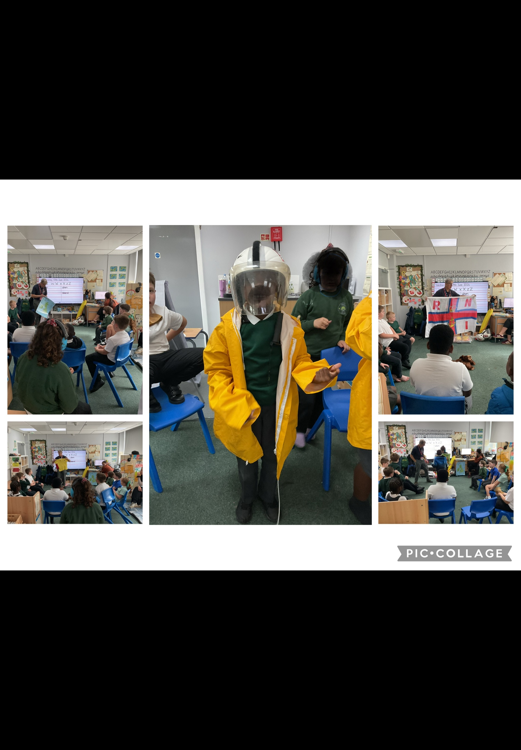

What a wonderful summer term we have had, what a wonderful year! The pupils have completed a variety of learning and personal development activities and thrived. We have been celebrating all the pupils’ achievements and success this year – there have been so many! Have a lovely summer.

Mr Caldwell (HT)

Summer Term
Willow Tree

