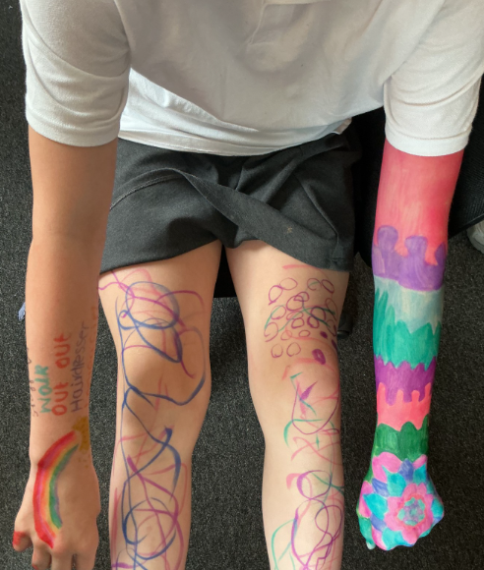
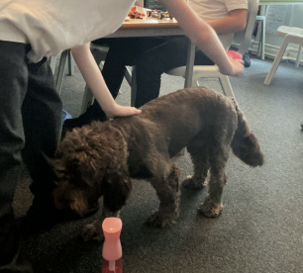
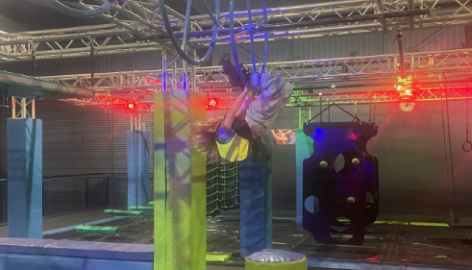
What a wonderful summer term we have had, what a wonderful year! The pupils have completed a variety of learning and personal development activities and thrived. We have been celebrating all the pupils’ achievements and success this year – there have been so many! Have a lovely summer.

Mr Caldwell (HT)

- 2nd September 2026 School opens
- 5th October 2026 INSET
- 23rd November INSET
- 11th December 2026 Family Morning

All of the children have been really engaged in completing the work needed for their AQA units. They have achieved some awards already this term and are enjoying finding units that match their interests.

The children have really enjoyed participating in our new weekly provision ‘Total Ninja’ this term. They’ve all shown brilliant levels of teamwork, determination and perseverance.

We’ll be exploring adventure and fantasy as our topics in the Autumn term. In English we’ll be looking at the short films ‘Adventures are the pits’ and ‘Cyber Kicks’ to support our writing. In Maths we’ll start by focusing on number before moving on to addition and subtraction. Classes will also be participating in the following on-site and off-site provisions- Projekts, Swimming, Gym, Total Ninja, Cooking and our AQA Units.
Summer Term
The Suns & Atlantis

