What a wonderful summer term we have had, what a wonderful year! The pupils have completed a variety of learning and personal development activities and thrived. We have been celebrating all the pupils’ achievements and success this year – there have been so many! Have a lovely summer,

Mr Caldwell (HT)
Summer 1: The children explored the theme Wriggle and Crawl. We spent lots of time outside observing minibeasts and their habitats, and then used a range of sources to research our favourite creatures. The children then used their findings to write a non-chronological report. In PSHE, we engaged in a workshop with the RNLI focusing on water safety.
Autumn 2: Our topic was Land Ahoy. We practised our peeling and chopping skills in D&T by making a delicious ‘Pirate Pasta’ dish. We also took a trip to New Brighton Beach where we enjoyed playing in the sand and sea, collecting natural objects, having a picnic and we even treated ourselves to an ice-cream!
In the Autum term we will be exploring the topics Muck, Mess and Mixtures and Bright Lights, Big Cities. We will be reading a range of fiction, non-fiction and poetry books in English, which will provide a stimulus for our writing. In PSHE the children will be learning about relationships and respecting themselves and others. Throughout the term in Maths, we will be covering a range of topics including place value, addition and subtraction and shape. The children will also be exploring skeletons and nutrition as part of our Animals including Humans topic in Science. We will be getting super messy in both Art and D&T as we explore colour and collaging!
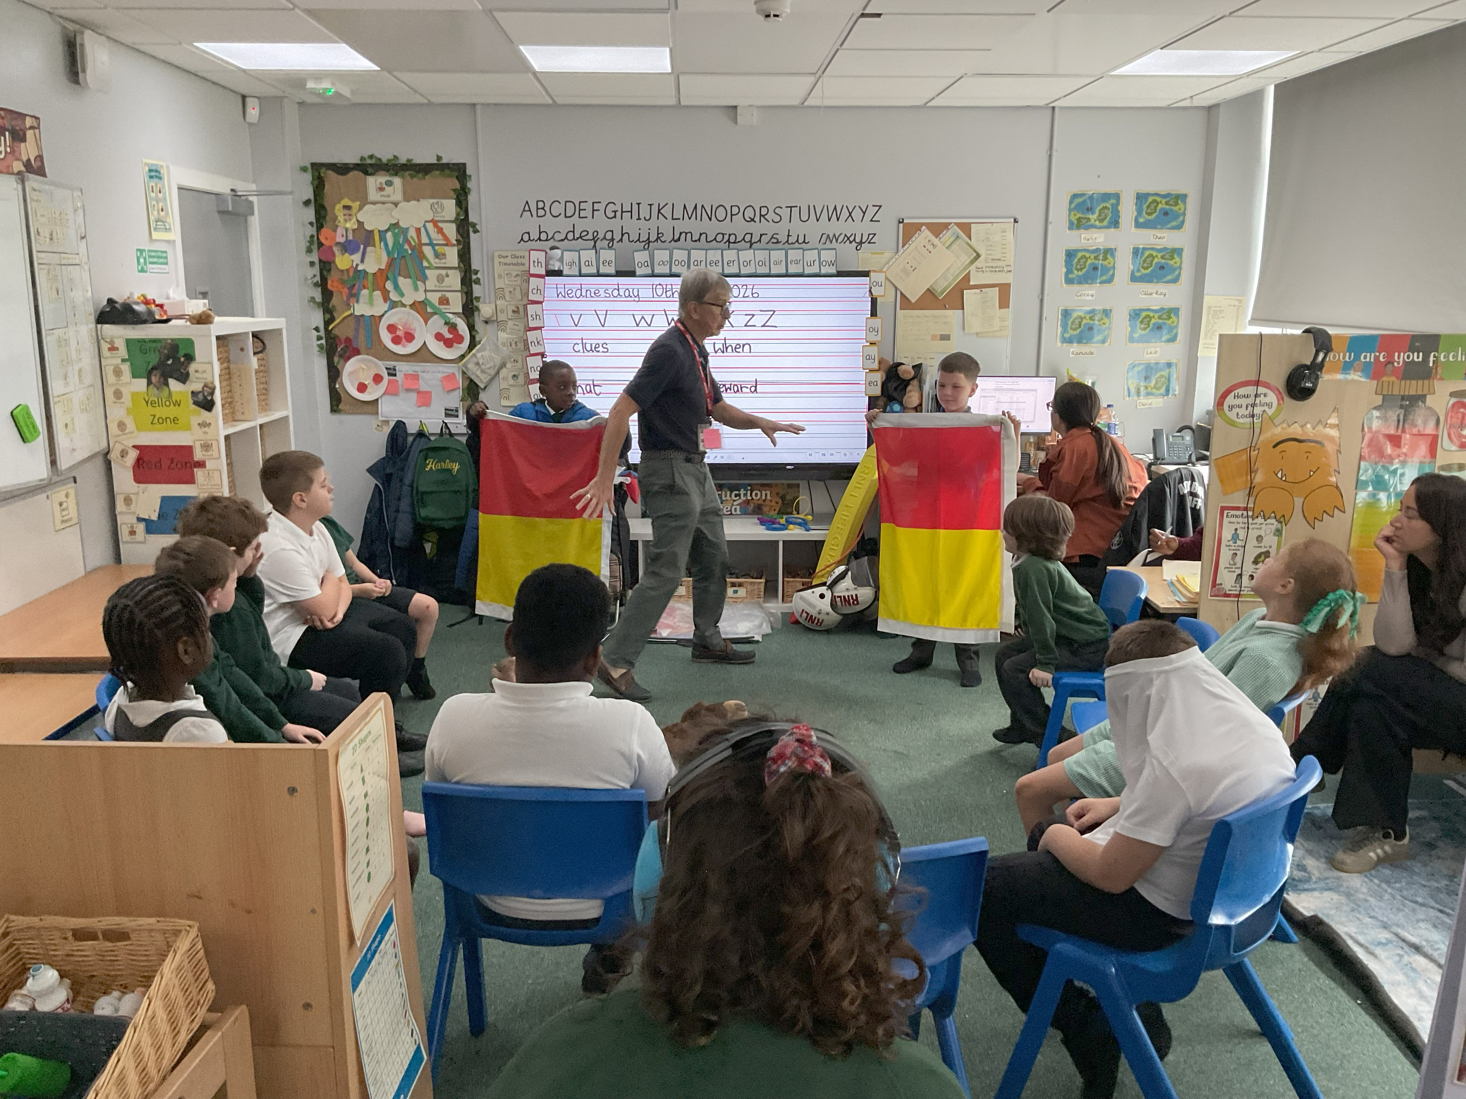
Summer Term
- School opens: Wednesday 2nd September 2026
- Family Messy Mixtures Morning: Friday 25th September 2026
- Family Cooking Session: TBC
- Salford Museum & Art Gallery: TBC
- Afternoon Tea Party: TBC
- Family morning 11th December 2026

Quayside

