What a wonderful summer term we have had, what a wonderful year! The pupils have completed a variety of learning and personal development activities and thrived. We have been celebrating all the pupils’ achievements and success this year – there have been so many! Have a lovely summer,

Mr Caldwell (HT)

- Parents morning – Friday 25th September 2026
- Parents morning – Friday 11th December 2026
- Messy Mixtures Morning- TBC
- Salford Museum and Art Gallery- TBC
- Afternoon Tea Party- TBC

Summer Term
Oak Tree

This term we have done lots of learning on our Wiggle and Crawl topic, and our Land Ahoy topic as well! We have accessed continuous provision on these themes, as well as English lessons, and we were also very excited to welcome the RNLI into school, who shared valuable information about their important role in saving lives at sea. In DT Spring 1 we made bug hotels, and looked at The Snail by Matisse in Art and created our own. We have looked at our local area in Geography, and History too- learning about Salford.
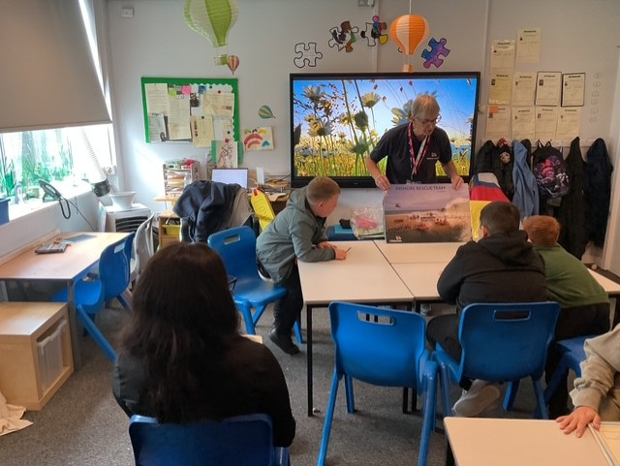

In Autumn 1 we will be looking at the theme Mess, Muck and Mixtures and in Autumn 2 our theme will be Bright Lights, Big Cities. We will be reading a range of fiction and non-fiction books, which will provide a stimulus for writing. In PSHE, the children will be looking at relationships. In Maths, throughout Autumn term, we will be covering a range of topics including place value, addition, subtraction and shape. Science will be looking at animals including humans, and Geography will look at local area including the UK. History will be based on big events in History, and Art will be looking at colour and collaging! In DT we will look at food and then joining and structures to round it off. We will have a messy mixtures morning, and an afternoon tea party and museum trip.
RNLI Visit

