What a wonderful summer term we have had, what a wonderful year! The pupils have completed a variety of learning and personal development activities and thrived. We have been celebrating all the pupils’ achievements and success this year – there have been so many! Have a lovely summer,

Mr Caldwell (HT)

Summer Term
Butterfly

What a fantastic summer term we've had!
We've loved starting mountain biking as part of our personal development programme, enjoyed our weekly visits to Total Ninja, and made the most of the sunny weather at Alderbrook with picnics, water fights, and plenty of ice lollies.
Our treat trip to Heaton Park was a highlight, where we paddled our boats on the lake and had lots of fun together.
Back in class, we've been busy baking, making slime, and sharing lots of laughter. It's been a wonderful term, and we wish everyone a happy and relaxing summer break

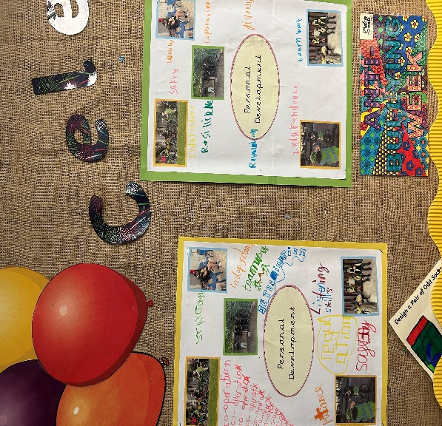

- 2nd September 2026 School opens
- 5th October 2026 – INSET
- 23rd November 2026 INSET
- 11th December 2026 family morning

We’ll be exploring adventure and fantasy as our topics for the Autumn Term. In English, we’ll be looking at the short films “Adventures Are The Pits” and “Cyber Kicks” to support our writing. In Maths we’ll start by focusing on number, before moving on to addition and subtraction. Classes will also be participating in the following on-site and off-site provisions – Projekts, Swimming, Gym, Total Ninja, Cooking and our AQA Units.

