Summer Term
Cherry Tree

What a wonderful summer term we have had, what a wonderful year! The pupils have completed a variety of learning and personal development activities and thrived. We have been celebrating all the pupils’ achievements and success this year – there have been so many! Have a lovely summer,

Mr Caldwell (HT)

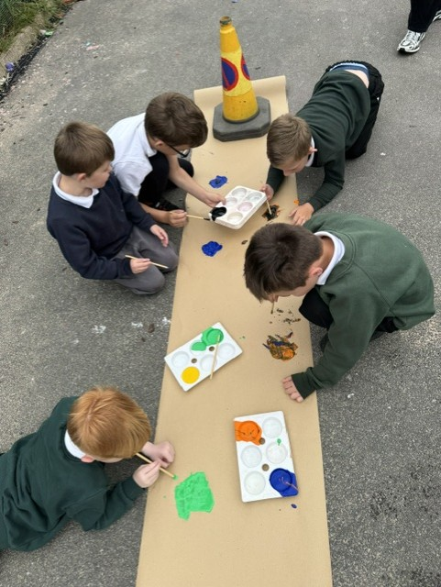

- Family morning – Friday 25th September 2026
- Family morning – Friday 11th December 2026

In Autumn 1 we will be looking at the theme Mess, Muck and Mixtures. In Autumn 2 our theme will be Superheroes. We will be reading a range of fiction and non-fiction books, which will provide a stimulus for writing. We will be using paints to explore colours, cooking and making potions.

In PSHE, the children will be looking at feelings and emotions. In Maths, throughout Autumn term, we will be covering a range of topics including counting, place value, addition, subtraction and shape. In science, we will be learning about animals, insects and our bodies.
Cherry Tree has had had a fantastic summer term and have had lots of fun. Our class topic was Land Ahoy! The children have enjoyed personal development such as the climbing wall and we have explored lots of activities in Tuff
Trays such as finding treasure and creating our own treasure maps.

In science we learned all about Neil Armstrong and did some lovely experiments. In maths we have been
working on patterns & shapes. We have finished our term by having a picnic and ice- cream in the field.

