Our pre-formal classes have been working very hard this past term! We have focused in maths developing number and using all four operations (+, -, x, ÷). We have introduced our Friday write – the children are making pleasing progress! We watch a short clip and use this as the stimulus for a short piece of writing each week, where we can apply our grammar learning. In PSHE we have focused on relationships, learning about bullying, consent and discrimination. Our weekly cooking sessions have seen our cooking skills developing weekly. We have also seen huge improvements in the children’s engagement with the gym sessions. Our off-site provisions- such as Projekts & Greystones have supported us to learn some important life skills while having immense amounts of fun! The children have also improved on their swimming abilities – important life skills to develop water safety and awareness, as well as different types of strokes.
Swimming commences again on a Tuesday – please ensure all children bring their full swimming kit & a towel. This is part of the National Curriculum, and not optional attendance.
Projekts and Greystones continue – (Projekts Mon & Thur, Greystones on Wednesday)
Cooking every Monday – if you would like to suggest a specific recipe or cooking skill, please do pass this onto your class lead.
The children are going to begin a new Personal Development Opportunity in Spring 2, taking place at the Boiler House. The children are going to be engaging in creative woodwork projects, making planters and a team approach to building a go-kart!

We have had a fabulous Autumn term at Alder Brook. We are a growing school with lots of new pupils who have joined us. We have also successfully opened a second site in Irlam. We call it “The Hub at Irlam”. In school we have had lots of fun learning. We have many personal development opportunities where pupils can learn and have fun together. This term we have also welcomed Erol & Mable who are our two new main site therapy dogs. Rudd and Hugo are still part of the team and are happy at The Hub and visit us often at main site. Have a lovely Christmas everyone.

Return to school: Tuesday 6th January
Great Athlete visit - 9th March
Spring family day – 2nd April
Half term dates: 16th -20th February
Easter holiday dates: 3rd April – 17th April
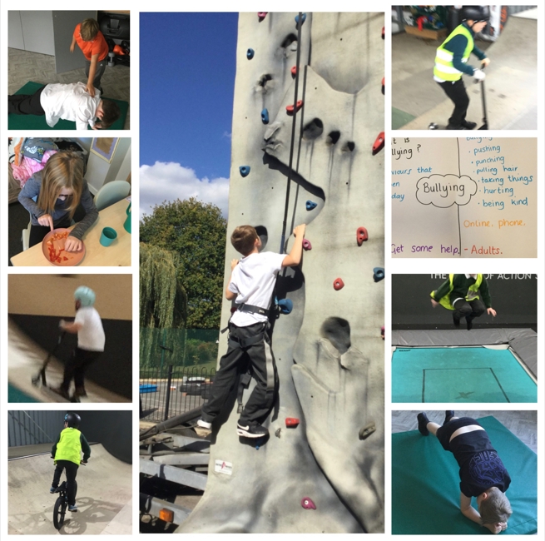
Spring Term
Sunrise & Sunset

