Autumn 2025

We have had a fabulous Autumn term at Alder Brook. We are a growing school with lots of new pupils who have joined us. We have also successfully opened a second site in Irlam. We call it “The Hub at Irlam”. In school we have had lots of fun learning. We have many personal development opportunities where pupils can learn and have fun together. This term we have also welcomed Erol & Mable who are our two new main site therapy dogs. Rudd and Hugo are still part of the team and are happy at The Hub and visit us often at main site. Have a lovely Christmas everyone.

Butterfly & Beehive
“Butter-hive”

In PSHE, Butterfly learned all about why Remembrance Day is so important. We talked about sacrifice, respect, and gratitude, and the children worked brilliantly together to create a vibrant collage filled with meaningful images and symbols to honour those who served.
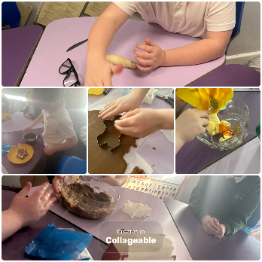
In Beehive, we’ve been busy becoming mini chefs! This term we’ve whipped up pizzas, biscuits, croissants, tuna salads, gingerbread biscuits, and even cakes. Our kitchen has been full of delicious smells, messy hands, and lots of proud smiles!

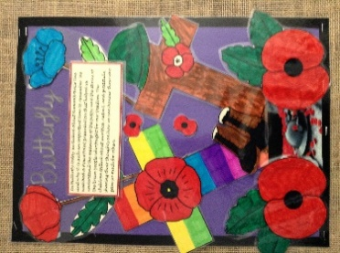


In the Spring term of 2026, we’ll be diving into the thrilling world of Greek Myths and Legends! Our adventure will begin with the captivating story of King Midas, where we’ll bring the myth to life through creative letter writing, step-by-step instructions, and bold, eye-catching posters. Our learning won’t stop in the classroom—this term is packed with exciting experiences! We’ll be exploring fascinating exhibits at the museum, discovering new ideas at the Boiler House, taking on challenges at Projekts, and enjoying action-packed biking sessions. It’s set to be a fun, inspiring, and unforgettable term!

- Tuesday 6th Jan-10th Feb – Swimming Butterfly
- Tuesday 24th Feb – 31st Mar – Swimming Beehive
- Every Tuesday – Projekts Butterhive
- Date TBA – Boiler house Beehive
- Every Wednesday – BMX Biking Butterfly
- People’s History Museum – Week Beginning 26th January.
- 2nd April 2026 Parents & carers morning

