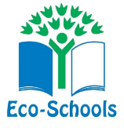
St Joseph’s Eco School Code
“We want to support the environment by making our school greener”

To achieve this we pledge to:
- Use less paper and reuse where possible
- Use less energy by turning off lights/electronic equipment when not in use
- Use less water by turning off the taps when not in use
- Waste less heat by closing the door when it is cold to keep the heat in
- Use the bins around school to keep our school tidy and prevent litter
- To recycle where possible
- To be more active and walk to school when possible
- To plant more flowers to improve the appearance of the school grounds

