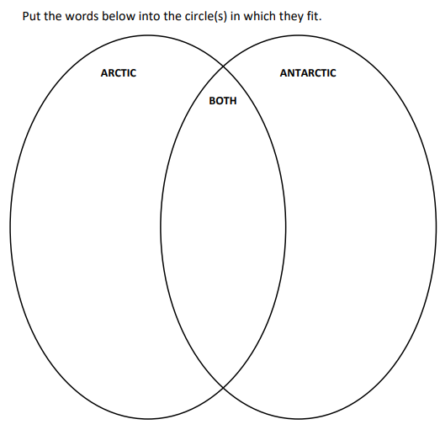
Key takeaways
- The weather can change over small distances in a country. Climate is the longer-term view of what any location’s general weather is usually like.
- The continents are all different from each other. Continents are so big that, within each one, there can be very varied conditions (hot, cold, wet, dry) at the same time.
- A major reason for this is how the weather and climate interact with the land. Some locations are near to the coast and sea, while others are far from them. Some land is high, such as a mountain, and some is flat for large distances. This affects the weather.
- In the UK, we have a climate that is warm in summer, cool in spring and autumn and cold in winter, with a mixture of wet and dry weather, and calm and windy spells. This produces our distinctive soil, flora and fauna, and impacts on the way we live.
- The world is split into different climactic zones. Each one has its distinctive character based on where it is in the world: polar, tropical, sub-tropical or equatorial.
- In the UK, we are in the temperate climate zone and temperate biome, and we have four seasons.
- The Tropics of Cancer and Capricorn are at 23 degrees north and south of the equator.
- In Antarctica in the winter months, the sea ice expands as more sea freezes. In summer months, some sea ice melts, which makes it difficult for polar bears to find food. The average winter temperature at the South Pole is about –49°C. (Your home freezer is only about –15°C.)
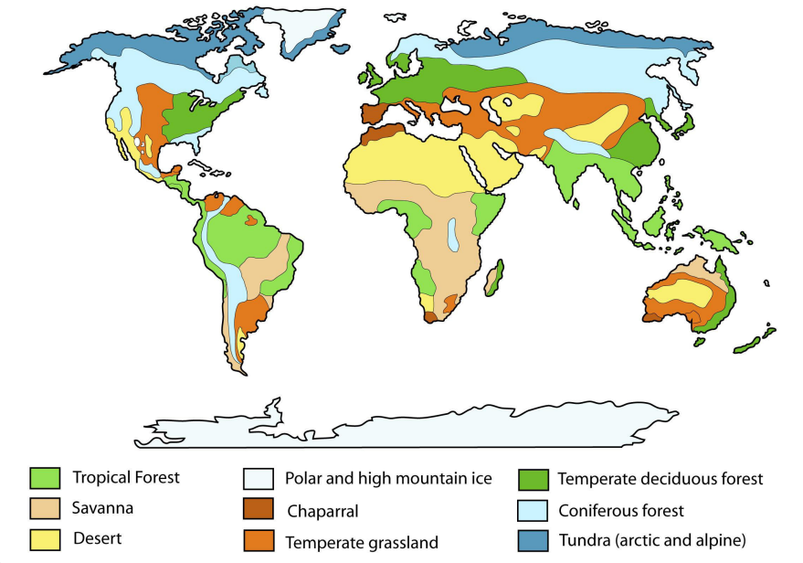

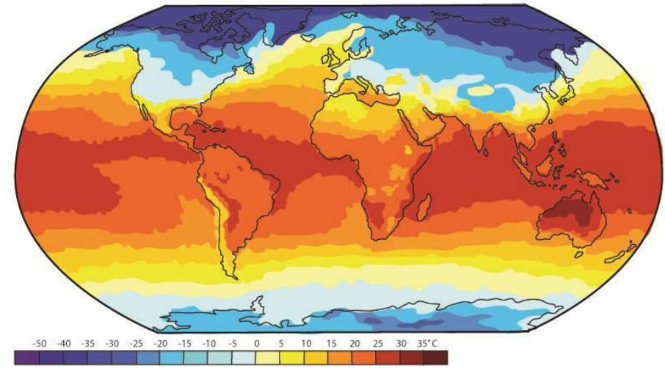
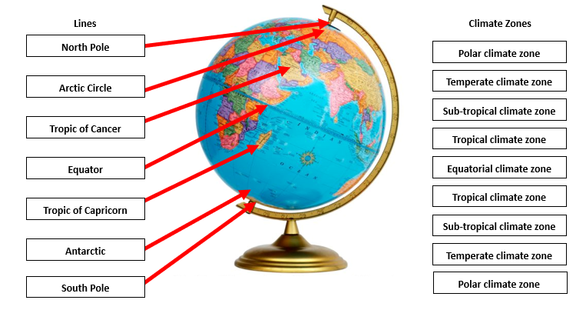
Try covering up the information on the right-hand side.

How much can you remember?
What does this map show?

Where are the five hottest locations to live in the world?

Where are the coldest five locations?
What does the map to the right in the middle show?

How is Oceania different from Asia?

How is Africa different from Europe?
What does the map to the right at the top show?

How is Africa different from Antarctica?

How is North America different from South America?
5 words to remember
biomes: including deserts, forests, grasslands, tundra and aquatic environments, biomes are defined by the climate, soil, organisms, flora and fauna of a large area; each biome consists of many ecosystems whose communities have adapted to the small differences in climate and the environment inside the biome
climate: the average weather pattern of a place over many years, in the long term; climates can be predominantly hot, cold, wet or dry; hot and wet; hot and dry; and so on – the climate of a place affects the soil, flora and fauna of that place, and impacts on human activity in a variety of ways
fauna: animals
flora: plants
weather: our atmosphere from day to day, in the short term; weather varies, and the range of weather in a place is a characteristic of its climate

