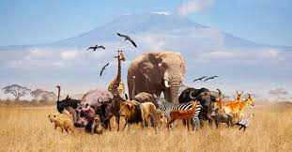
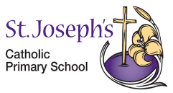
Animals including Humans- Life Cycles
KNOWLEDGE ORGANISER

What you should already know…
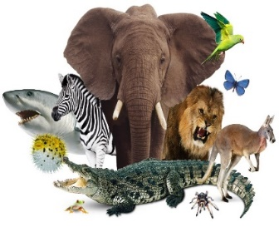  - Some animals give birth to live young  - Some animals lay eggs which the young hatch from.  - Both of these types of young develop into adults  - Some offspring look like their adult when they are born.  - Some offspring do not look like their adult when they are born. |  |  |  | 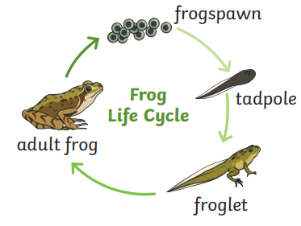  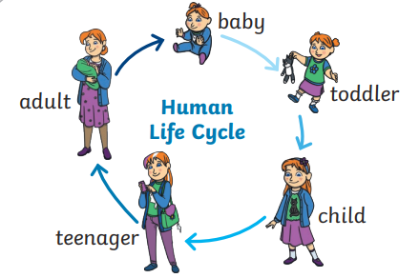
 |  |  |  | All young animals change as they go through different stages of their life cycle and grow into adult.
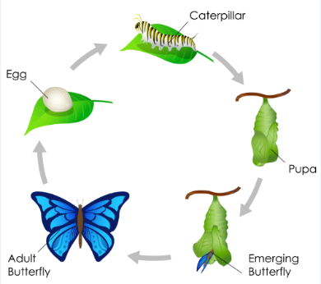
Key Vocabulary
adult | A fully grown animal or plant
develop | To grow bigger or become stronger.
Life cycle | The changes living things go through to become and adult.
offspring | The child of an animal.
young | Offspring that has not reached adulthood.
Live young | Offspring that has not hatched from and egg
