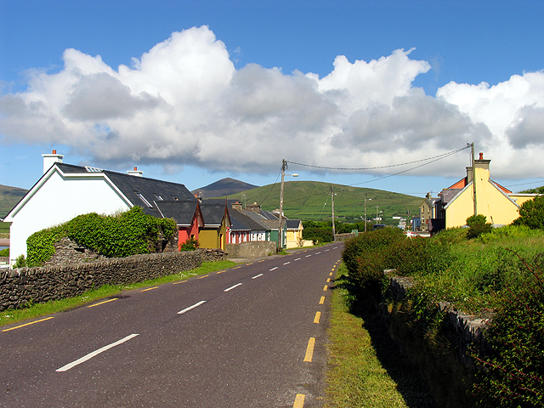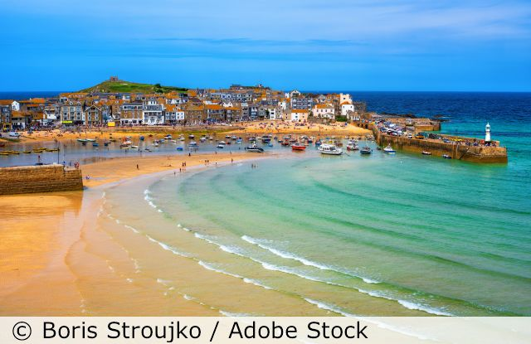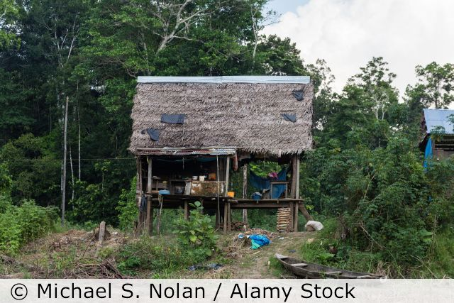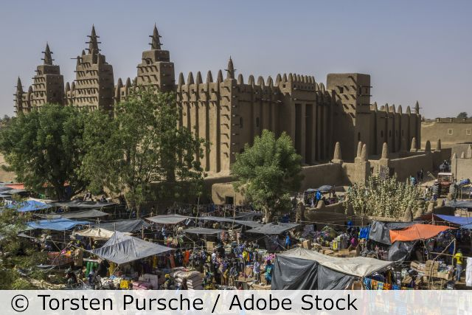
Important things to know
- We live in the North, South, East or West of our country. Which part of your country do you live in?
- We live in England, Scotland, Wales or Northern Ireland. Which nation do you live in?
- The coast is by the sea. A lifeguard might work there.
- A tropical rainforest biome is very different from the UK.
- People often use materials from nearby to construct their buildings.
- Building materials include bricks fired from clay in the UK, mud in Mali or wood from trees from the Amazon rainforest in Brazil.
- Millions of people group together in cities to live, work, meet and make things.
- Europe, Africa and South America and are all continents. North America, Asia, Oceania and Antarctica are the others – there are seven in total.
- Remember there are five oceans too! Can you name them?
[Atlantic, Pacific, Indian, Arctic, Southern]

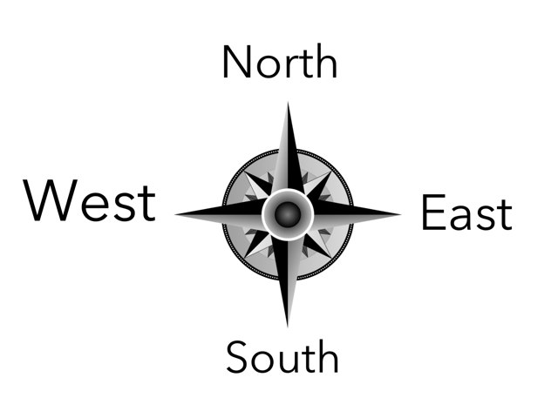
Coastline in the UK

Home in the Amazon rainforest | The Great Mosque in Djenné, Mali

5 words to remember
city
coast
England, Scotland, Wales, Northern Ireland
North, South, East, West
rainforest

