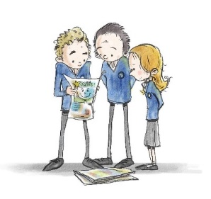
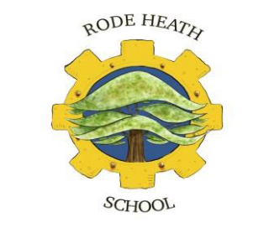
Rode Heath Primary School
School Council Mission Statement 2026 - 2027

We are the Year 6 representatives (Henry, Lillie, Scarlett and William) for the School Council our aims for this year are to:
- Take other pupils’ ideas forward to meetings to ensure that everybody has a voice.
- Continue to be excellent role models for the school.
- Make our presence known across all classes in school, for example reading with Reception and Year 1 children.
- Improve the sustainability of our school, and encourage more plant growth on the school grounds.
- Host a variety of fundraising events to raise money for the MacMillan, Food bank and Women’s Refugee and other causes throughout the year.

Our school council representatives from each year group are:
Year 2: Eva and Juno
Year 3: Addison and Arlo
Year 4: Helena and Noah
Year 5: Sebastian and Brayden
Year 6: Henry, Lillie, Scarlett and William

