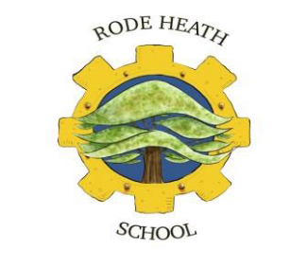

Rode Heath Primary School
School Councillors
Job Description
Rode Heath School Councillors require many qualities, below are a list of qualities and some job descriptions required when taking up the role of a School Councillor:
Qualities/Skills Required
- Must be approachable, a good listener and have an excellent relationship with all children
- A positive role model, kind and caring and a good attitude towards learning and has exemplary behaviour
- Be a good team member
- Must be organised and be a good timekeeper
- Must be confident and speak clearly
- Willing to bring ideas to meetings, listen to others and to be realistic about what can be achieved
- Willing to give up your own time to help, come to meetings or prepare something
- Well-presented in uniform and appearance

Our School Councillors have been elected by their class peers through a fair election process. We will have 12 School Councillors in total, two children from each year group from year 2 apart from year 6 where there will be four representatives. Their job role is very important throughout the school and below you will see a list of jobs our School Councillors will undertake throughout the school year.

Jobs:
- Take on the role of a junior safeguarding lead to help give advice to the children on matters such as digital online-safety, bullying and health care.
- Representing the voice of the children of Rode Heath Primary School
- Working with teachers to make decisions which will improve the school
- Attending meetings regularly and on time and work closely with the School Council adult.
- Listening to and collecting ideas from your class and sharing them at council meetings
- Leading and helping in assemblies and class meetings
- Deciding on and organising events
- Representing Rode Heath Primary School both in school and out of school when called upon

