



September 2026

Dear Parents/Carers,

Happy September!

It has been an absolute pleasure to see all of the children back at school, in their new classes, at their desks, working hard and enjoying the many exciting activities planned by their teachers and support staff. Firstly, I would like to give an extra special welcome to all our new children in Pre-school, Reception and the small number of new staff who have joined our school.
At the beginning of the academic year, one of our main priorities is to establish routines for both children and parents/carers. The information below is to help communicate some of these routines.

Attendance matters

At Rode Heath Primary School, we know that every day in school matters. While attendance remained positive overall, we saw a slight dip last year, and we are asking for your support in helping us reverse this trend. The link between attendance and achievement is clear: children who attend school regularly make better progress academically, develop stronger friendships, grow in confidence and benefit more fully from the rich experiences we provide.
Although 1% may sound insignificant, it equates to almost two full days of learning missed across an academic year. An attendance rate of 95% means a child misses around 10 school days, the equivalent of two weeks of education, while 90% attendance results in nearly four weeks of missed learning. These lost days cannot be fully replaced and can leave children feeling less confident and having to work harder to catch up.
We understand that children will occasionally be unwell, but wherever possible, we encourage families to prioritise attendance and avoid taking holidays during term time. By working together, we can ensure every child benefits from every lesson, every opportunity and every chance to thrive.

School Day

Pre-School: 9am – 3pm
Reception and Key Stage One: 8:45am – 3:15pm
Key Stage Two: 8:50am - 3:20pm (doors open from 8:40)
Please note that there is no supervision before 8:40am and unaccompanied children should not be on the school site before this time. If your child arrives after the start of the school day, they must enter the building by the front entrance. This will cause an added delay to your child’s learning and disrupt the start of the school day for other learners. Please ensure your child is on time with all of the necessary school equipment, PE kit, lunch box etc., in order to make the most of each school day.

Penalty Notices

Arrivals after the close of the register are given an unauthorised code. Persistent lateness and absence is monitored by the Education Welfare Officer and in accordance with Cheshire East.

With the National Framework for Penalty Notices, Cheshire East have made the follow rules which schools must abide by:
- Fines will be issued for term time leave of 5 or more consecutive days.
- Fines may be issued when there has been 10 sessions of unauthorized absences in a 10 week period; however, a Penalty Notice may be issued before this threshold is met if it is felt parents are deliberately avoiding the national threshold by taking several term time holidays.

Further information on the DfE guidance can be accessed via this link: Working together to improve school attendance (applies from 19 August 2024) (publishing.service.gov.uk)

School Office

The office is open from 8:30am until 3:30pm each day (term time only). This is to ensure we maximise our funding to support the education of each and every child. Outside of these hours parents/carers can leave a message that will be acted upon as soon as possible. Contact for our All Stars before and after school provision (outside of office hours) is via 07511234505.

Illness

If your child is ill and will not be attending school, please phone the school from 8:30am on the first morning of the illness to speak to a member of staff or you can leave a voicemail prior to this time. If we have not received a phone call by 9.15am, the school office staff will contact you by phone asking you to contact school immediately. The safety of your child is paramount.

Newsletters/Letters

The school newsletter is the main source of practical information provided to families and is produced monthly. Please read the newsletters carefully and make a note of the information relating to your child. All letters are sent out via School Spider. Copies of all letters and newsletters can be found on the school website. Please note it is your responsibility to make the school aware of any contact information changes.

Home-School Communication

We pride ourselves on always being approachable to parents/carers. Parents/carers are encouraged to speak to class teachers or senior staff if they are concerned about their child’s welfare or educational progress. However, the start of the school day is very important for all children so I would ask parents/carers to be mindful of this when speaking to teachers before school. If you feel your discussions need longer than a few comments please contact school to make an appointment or speak to me as I will always be outside the front of school every morning.

Parents/carers are encouraged to write messages pertinent to that day in your child’s reading diary. However, children must bring this to the attention of their teacher as the reading diaries are only routinely checked once a week.

Meet the Teacher
To help your child settle confidently into their new class and to ensure you are fully informed about the year ahead, we invite you to attend one of our Meet the Teacher sessions.
These meetings will be held face-to-face on Wednesday 9th September, with two sessions available at 3:45pm and 5:30pm (they are both the same session).
During the meeting, your child's teacher will explain the curriculum for the year, daily routines, class expectations, homework arrangements and key events planned for the months ahead. It is also a valuable opportunity to find out how you can support your child’s learning at home and ensure they make the most of every opportunity throughout the year.

We strongly encourage all parents and carers to attend one of these sessions.

The Triangle of Success
At Rode Heath, we believe the best outcomes for children come when school, home and the child work together. We often refer to this as our Triangle of Success. We are committed to providing high-quality teaching, care and support in school, but we cannot do it alone. The role that parents and carers play is equally important.
One of the biggest factors influencing children's progress is the support they receive at home. Simple activities such as listening to your child read, practising phonics, helping them learn spellings, and regular maths practice can make a huge difference. For younger children, secure number bonds provide the foundation for future learning, while for older children, confidence with times tables is essential.
We understand that family life is busy and finding time can be difficult. However, even a few minutes each day can have a significant impact. Time and again, we see a clear link between children who practise little and often at home and those who achieve well in school. By working together, we can give every child the very best chance to succeed and thrive.
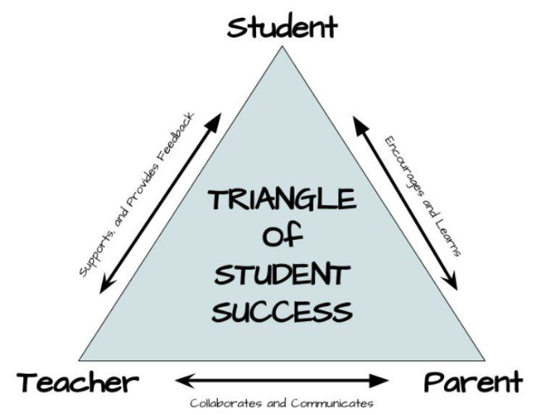

Reading Diaries

We have now handed out all of the reading diaries so please ensure that you update the permissions section as soon as possible so we can update our systems. Year 5 and 6 children need to also bring back their walking home permissions slip by the end of this week in order for them to be able to walk home by themselves; this will commence next week.

School Meals

The current school meal menu, which runs until mid-October, is on the school website. Please follow the link: Rode Heath Primary: School Dinners & Menus

Health and Safety

Anaphylaxis – Allergy to Nuts
We insist that children do not bring nuts and products containing nuts into school. We currently have a number of children in school with allergies who require an EpiPen on site should they come into contact with nuts. The school kitchen has had this policy in place for a number of years and we request that this is the case for packed lunches and also break time snacks. This includes some cereal bars and chocolate bars that contain nuts. The children will be reminded about this in an assembly and it will be reiterated that they have a responsibility to support and protect their friends in our caring community. More information about anaphylaxis can be found at http://www.epipen.co.uk/

School Equipment / Uniform

With limited cloakroom space within school, we request that children refrain from bringing large bags/rucksacks. We encourage the children to bring their homework and reading materials in a school book bag (or a satchel of the same size). Also, please can any snacks or water bottles sent in with your child NOT be placed in reading folders as we are regularly throwing books away due to water and food damage.

The school has always aimed for a straight-forward and pragmatic uniform policy for all parents/carers to follow ie, plain black shoes, boots for the winter months (should they be needed), hair accessories of school colours with the minimum of detail and single ear-studs. No make-up or nail varnish is permitted. More details available from this link. http://www.rodeheath.cheshire.sch.uk/page/our-uniform/11089

Class Web Pages
Please refer to your class’s web page on our school website for all of the pertinent information that you will need for this half term. This will include PE days, their weekly learning journeys, academic expectations, Renaissance reading links, etc. Here is a link to our school website: Rode Heath Primary: Welcome to our school...
Our school Facebook feed is updated regularly. www.facebook.com/rodeheathschool
I am really looking forward to another very successful year ahead,
John Frankland
Headteacher

