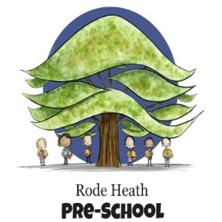
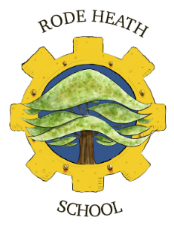

Jodrell Bank Year 5 Trip

Dear Parents/Carers,
As part of our topic study about Space, we are going to visit the Jodrell Bank Observatory in Lower Withington on Friday 7th November 2025. We aim to leave school at 9.20am and return before the end of the school day at 3.00pm. Your child will need a packed lunch, snack and a drink (no fizzy drinks, or glass bottles, please). Please ensure your child wears school uniform for our trip to the observatory. Also, please can your child bring a waterproof coat due to the time of year.
The cost of this trip is £21.70, the payment and consent can be accessed and completed via your online Scopay account. Please pay by Friday 31st October to secure your child’s place.
If you have any queries regarding this trip, please do not hesitate to contact me.

Yours sincerely,
Miss Watson

