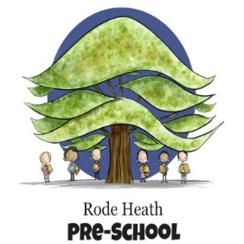
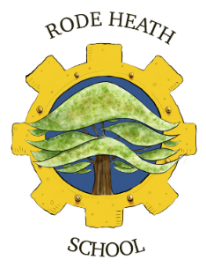
Wednesday 10th September, 2025
Year 4 – Bolton Museum Trip
Dear Parents/Carers,
This term our history focus is on Ancient Egypt and to enhance the children’s experience of this fascinating period, we have booked a trip to Bolton Museum on Monday 29th September. The day will consist of a 90-minute workshop, which will take place inside a replica tomb. The children will learn about the mysterious mummification process through detailed discussions and observing the ancient artefacts and mummified remains on display in the galleries. The rest of our time will be spent self-guided around the rest of the building.

We will be leaving school at 9:15 am and aim to be back for the end of the school day. The cost of the trip will be £ 19.00. Payment and consent can be made via your scopay account. Your child’s place is not secure until consent and payment is made.
The children will need a packed lunch (children on free school meals will be provided with a packed lunch) and a couple of drinks (no cans or glass bottles please!) in a suitable hands-free bag such as a rucksack. The children need to wear school uniform and bring a waterproof coat.

Kind regards

Mrs Wiskow & Mrs Pecora

