
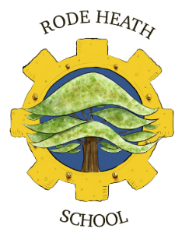
11/09/25
Dear Parents/Carers,
We have arranged an exciting visit for the Year 3 children to the National Waterways Museum at Ellesmere Port on Wednesday 1st October 2025 as part of their work on Canals.
We aim to leave school at 9.10am and return for approximately 3.35pm. Your child will need a packed lunch, a (non-fizzy) drink in a plastic bottle carried in a ruck-sack so they are hands free throughout the visit. Children will be required to wear their school uniform for the trip. Please remember to bring a waterproof coat and wear suitable footwear.
The cost of the trip is £21.70 payment and consent can be accessed and completed via your scopay account. Please complete this online by Monday 22nd September to secure your child’s place.

Yours sincerely
Mr Randall

