
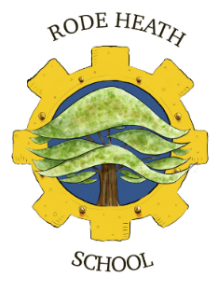

All Stars OOH Club (Out of Hours) School Club Terms & Conditions

All bookings for our Out of Hours provisions can be made via your Scopay account. Payment will be required at time of booking. Any Adhoc sessions that are booked through the school office (within 48hrs of the day of booking) payment will be required via your scopay account within 24hrs of the booking being made.
Late payment of adhoc bookings will incur an administration charge of £20 and will be invoiced for immediate payment.
All pick-up times must be adhered too, late pick-ups will incur an administration charge of £20.00 per child which will again be invoiced for immediate payment.
The morning sessions available are;
- Long Breakfast Club (includes breakfast) from 7.30am - £6.50
- Short Breakfast Club (does not include breakfast) from 8.15am - £4.00
The afternoon sessions available are:
- Short until 4.00pm session (does not include snack) - £4.50
- Long until 6.00pm (includes a snack at 4pm) - £9.50
Bookings can only be changed/cancelled with 48hrs notice of the session via your scopay account or by contacting the school office. Any sessions missed due to illness, change in circumstances or a leave of absence are non-refundable or transferable.

