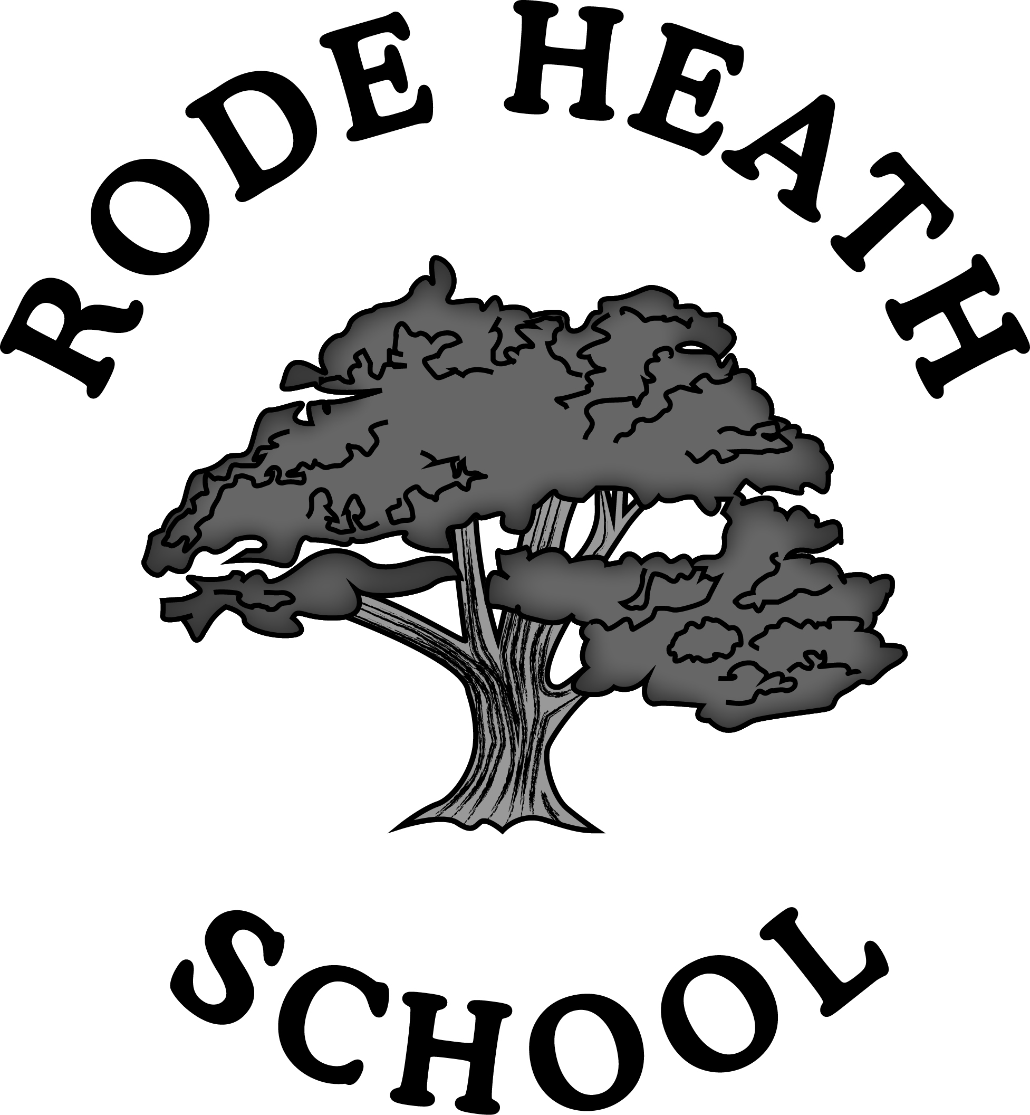

PRIVACY NOTICE FOR PUPILS, PARENTS AND GUARDIANS
Privacy Notice (How we use pupil information)

Why do we collect and use pupil information?
Rode Heath Primary School collect and process pupil information as part of our public functions under both the Data Protection Act 1998 and General Data Protection Regulation. An example of this is the school census return which is a statutory requirement on schools under Section 537A of the Education Act 1996.
We use the pupil data:
- to support pupil learning
- to monitor and report on pupil progress and the national curriculum
- to provide appropriate pastoral care
- to assess the quality of our services
- to comply with the law regarding data sharing
- to enable our parents to make online payments
- to enable communication with parents (ie Teachers2 Parents)
- to report to the Governor Body to enable them to carry out their statutory duties
- to meet our statutory duties in relation to reporting (ie information on the school website)
- to comply with statutory duties in relation to safeguarding pupils

The categories of pupil information that we collect, hold and share include:
- Personal information (such as name, unique pupil number and address)
- Characteristics (such as ethnicity, language, nationality, country of birth, free school meal eligibility, dietary and allergen information)
- Attendance information (such as sessions attended, number of absences, absence reasons and punctuality)
- Assessment information
- Exclusions/behavioural information
- Relevant medical information
- Special educational needs information

Collecting pupil information
Whilst the majority of pupil information you provide to us is mandatory, some of it is provided to us on a voluntary basis. In order to comply with the General Data Protection Regulation, we will inform you whether you are required to provide certain pupil information to us or if you have a choice in this.

Storing pupil data
We hold pupil data in accordance with our Retention Policy Schedule and Cheshire East Guidance.

How will my information be stored?
We store all pupil data securely on encrypted devices and on the GDPR Platform/SIMS database.

Who do we share pupil information with?
We routinely share pupil information with:
- schools that the pupils attend after leaving us
- our local authority
- the Department for Education (DfE)
- NHS/Social Care
- the partners listed below:

Capita (Sims)
GroupCall
Nessy
RM Maths
EducationCity
CPOMS (Meritec)
Renaissance
Amaven PE Testing
Scopay
Learning Book
School Spider
Tucasi
Tinkercard
Learning Book

Why we share pupil information
We do not share information about our pupils with anyone without consent unless the law allows us to do so.

We share pupils’ data with the Department for Education (DfE) on a statutory basis. This data sharing underpins school funding and educational attainment policy and monitoring.

We are required to share information about our pupils with our local authority (LA) and the Department for Education (DfE) under section 3 of The Education (Information About Individual Pupils) (England) Regulations 2013.

Data collection requirements:
To find out more about the data collection requirements placed on us by the Department for Education (for example; via the school census) go to https://www.gov.uk/education/data-collection-and-censuses-for-schools.

The National Pupil Database (NPD)
The NPD is owned and managed by the Department for Education and contains information about pupils in schools in England. It provides invaluable evidence on educational performance to inform independent research, as well as studies commissioned by the Department. It is held in electronic format for statistical purposes. This information is securely collected from a range of sources including schools, local authorities and awarding bodies.

We are required by law, to provide information about our pupils to the DfE as part of statutory data collections such as the school census and early years’ census. Some of this information is then stored in the NPD. The law that allows this is the Education (Information About Individual Pupils) (England) Regulations 2013.

To find out more about the pupil information we share with the department, for the purpose of data collections, go to https://www.gov.uk/education/data-collection-and-censuses-for-schools.

To find out more about the NPD, go to https://www.gov.uk/government/publications/national-pupil-database-user-guide-and-supporting-information.

The department may share information about our pupils from the NPD with third parties who promote the education or well-being of children in England by:

- conducting research or analysis
- producing statistics
- providing information, advice or guidance

The Department has robust processes in place to ensure the confidentiality of our data is maintained and there are stringent controls in place regarding access and use of the data. Decisions on whether DfE releases data to third parties are subject to a strict approval process and based on a detailed assessment of:

- who is requesting the data
- the purpose for which it is required
- the level and sensitivity of data requested:
- the arrangements in place to store and handle the data

To be granted access to pupil information, organisations must comply with strict terms and conditions covering the confidentiality and handling of the data, security arrangements and retention and use of the data in compliance with the GDPR.

For more information about the department’s data sharing process, please visit:
https://www.gov.uk/data-protection-how-we-collect-and-share-research-data

For information about which organisations the department has provided pupil information, (and for which project), please visit the following website:
https://www.gov.uk/government/publications/national-pupil-database-requests-received

To contact DfE: https://www.gov.uk/contact-dfe

Information may be used to take automated decisions about your child.
Should a pupil move overseas, data may be shared with the new educational provider.

Requesting access to your personal data
You have the right under the Data Protection Act 1998 (General Data Protection Regulation) to request a copy of your information and to know what it is used for and how it has been shared. This is called the right of subject access.
To make a request for your personal information, or be given access to your child’s educational record, contact Mrs Edyta Hicklin, Data Protection Administrator at: sbm@rodeheath.cheshire.sch.uk

You also have the right to:
- object to processing of personal data that is likely to cause, or is causing, damage or distress
- prevent processing for the purpose of direct marketing
- object to decisions being taken by automated means
- in certain circumstances, have inaccurate personal data rectified, blocked, erased or destroyed; and
- claim compensation for damages caused by a breach of the Data Protection regulations

If you have a concern about the way we are collecting or using your personal data, you should raise your concern with us in the first instance or directly to the Information Commissioner’s Office at https://ico.org.uk/concerns/
Contact:
If you would like to discuss anything in this Privacy Notice, please contact:
Mrs Edyta Hicklin, Data Protection Administrator at: sbm@rodeheath.cheshire.sch.uk


DATA MAPPING
Incoming Data Source Outgoing Data

OTHER SCHOOLS
CAPITA
sims

Amaven PE

GROUPCALL

PRE-SCHOOL

NESSY

EDUCATIONCITY
LA

PARENTS/CARERS

NHS

POLICE

SOCIAL CARE
SCOPEPAY
PUPIL
Local Authority
Other schools
TUCASI
LEARNING BOOK
SCHOOL SPIDER

TRUST GOV
RM Maths

ICT SUPPORT

RENAISSANCE

CPOMS
(Meritec)

SOCIAL CARE

NHS

LOCAL AUTHORITY

