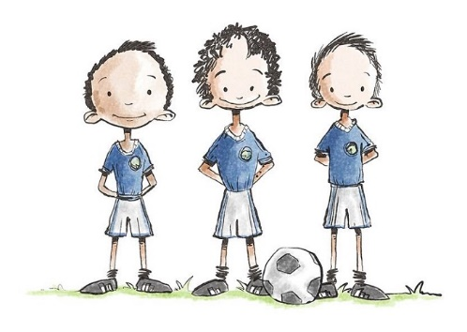
Rode Heath Primary School
Sporting Ambassadors
Job Description
Rode Heath Sporting Ambassadors require a lot of qualities, below are a list of qualities and some job descriptions required when taking up the role of a Sports Ambassador:

Qualities/Skills Required
- Must be approachable and have a good relationship with all children
- A positive role model and an excellent attitude towards learning and playing sports
- Be a good team member
- Able to engage and inspire others
- Must be organised and be a good timekeeper
- Well-presented in uniform and appearance

Our Sporting Ambassadors have been carefully chosen and show all of the qualities above. We will have nine ambassadors in total, three children from Year 4, from Year 5 and from Year 6. Their job role is very important throughout the school and below you will see a list of jobs our Sporting Ambassadors will undertake throughout the school year.
Jobs:
- Advertise and promote healthy living, including daily exercise and healthy snacks in and around school
- Run break/lunch time activities on the KS1 and KS2 playground
- Help run and organise Intra house competitions
- Be ready for other Sporting needs throughout the year
- Raise the profile and to be ambassadors of the daily mile
- Regularly update the school in assemblies and on the sports noticeboard on our performances in school competitions
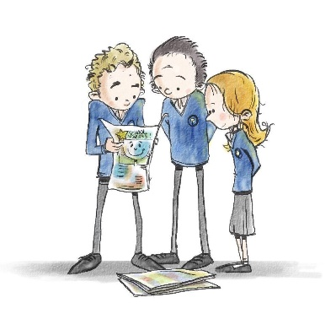
Rode Heath Primary School
School Councillors
Job Description
Rode Heath School Councillors require a lot of qualities, below are a list of qualities and some job descriptions required when taking up the role of a School Councillor:

Qualities/Skills Required
- Must be approachable, a good listener and have an excellent relationship with all children
- A positive role model, kind and caring and a good attitude towards learning and has exemplary behaviour
- Be a good team member
- Must be organised and be a good timekeeper
- Must be confident and speak clearly
- Willing to bring ideas to meetings, listen to others and to be realistic about what can be achieved
- Willing to give up your own time to help, come to meetings or prepare something
- Well-presented in uniform and appearance

Our School Councillors have been elected by their class peers through a fair election process. We will have 14 School Councillors in total, two children from each year group apart from year 6 where there will be four representatives. Their job role is very important throughout the school and below you will see a list of jobs our School Councillors will undertake throughout the school year.

Jobs:
- Take on the role of a junior safeguarding lead to help give advice to the children on matters such as e-safety, bullying and health
- Representing the voice of the children of Rode Heath Primary School
- Working with teachers to make decisions which will improve the school
- Attending meetings regularly and on time and work closely with the School Council adult.
- Listening to and collecting ideas from your class and sharing them at council meetings
- Leading and helping in assemblies and class meetings
- Deciding on and organising events
- Representing Rode Heath Primary School both in school and out of school when called upon

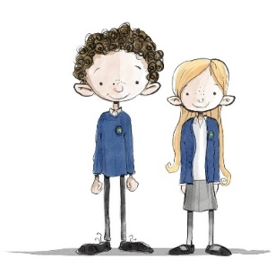
Rode Heath Primary School
House and Vice-House Captains
Job Description

Rode Heath House and Vice-House Captains require a lot of qualities, below are a list of qualities and some job descriptions required when taking up the role of a House or Vice-House captain:

Qualities/Skills Required

- Must be approachable, a good listener and have an excellent relationship with all children
- A positive role model, kind and caring and a good attitude towards learning and has exemplary behaviour
- Be a good team member
- Must be organised and be a good timekeeper
- Must be confident and speak clearly
- Willing to bring ideas to meetings, listen to others and to be realistic about what can be achieved
- Willing to give up your own time to help, come to meetings or prepare something
- Well-presented in uniform and appearance

The role of House and Vice House Captains are ones of privilege, pride and responsibility. They are more than just a title and badge and require dedication and commitment for two years. Our Vice-House Captains are elected by their class peers at the end of year 4 through a fair election process. These children act as Vice Captains throughout their time in Year 5 and then become House Captains once they are in Year 6. At this point, the process of electing new Vice Captains begins again.

Jobs:
- Lead and support the children of your House in a variety of House Competitions
- Work closely with the House Lead teacher, providing ideas and support for competitions and House related activities
- Help organise and lead regular House Meetings
- Collect, monitor and announce House Points
- Inspire the children of your House
- Be an excellent role model in behaviour, attitude and dress at all times
- Act as corridor monitors during assemblies
- Representing Rode Heath Primary School both in school and out of school when called upon

