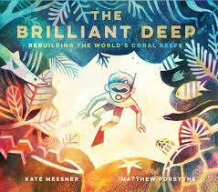
English – Our English writing will be based on the book ‘The Brilliant Deep’ by Kate Messner and Matthew Forsythe. We will be using this text to write an information leaflet to persuade children to consider the effects of climate change on
coral reefs
Children will be using precise word choices and emotive language including use of modals and adverbs for possibility (e.g. surely, every right-thinking person would). They will also use persuasive language: quotes and rhetorical questions

Grammar & Punctuation – We will be looking at different types of pronouns such as relative, personal, possessive and indefinite. looking at a range of conjunctions. Then we will focus on using the correct tenses consistently and identifying determiners.

Guided Reading – We will be using the text to identify and discuss themes and conventions. We will predict what might happen from details stated and implied and summarise main ideas and identifying key details. We will also retrieve, record and present information from non-fiction.

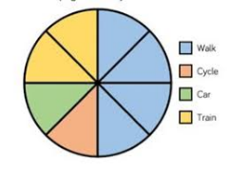
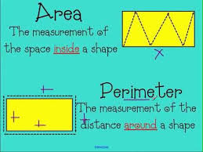
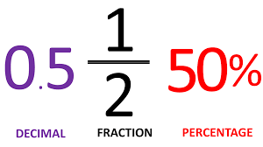
Maths – We will be exploring:
1. Decimals and percentages
2. Perimeter and area
3. Statistics.

Science – In science, we will be learning about ‘Animals including humans’. Children will learn to describe the changes as humans and animals develop to old age.
Geography – In geography, we will be learning ‘Why do oceans matter?’
P.E – Our PE unit this half term is going to be dance and dodgeball.
R.E. – The focus of our RE lessons this half term will be ‘Why is the Torah so important to Jewish people?’
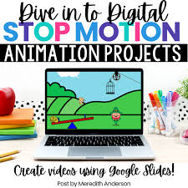
ICT – We are going to be looking at creating media and stop motion animation.

Spanish - We will be learning key phrases and vocabulary to describe the weather (continued)
Music - This half term we will be learning to play the Ukulele (continued)
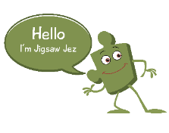
Jigsaw - In PSHE this half term our topic will be (Healthy Me). We will learn about: the health risks of smoking, the health risks of misusing alcohol, how to practice basic emergency aid, procedures (including recovery position), how to get help in an emergency situation, how body image may be influenced by media, the different roles food can play in people’s lives, eating problems and body image pressures
Art - Sculpture and 3D interactive instillation.
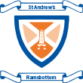
Year 5 Spring 2 Topic Plan

