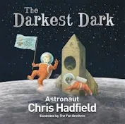
English – Our English writing will be based on the book ‘The Darkest Dark’ by Chris Hadfield. We will be using this text to write a biography and some short stories.
Children be further developing their vocabulary, identifying the audience and purpose of writing and developing initial ideas by drawing on reading and research.

Grammar & Punctuation – We will be revising main and subordinate clauses and looking at a range of conjunctions. Then we will focus on using the correct tenses consistently and identifying determiners.

Guided Reading – We will be using the text to identify and discuss themes and conventions. We will predict what might happen from details stated and implied and summarise main ideas and identifying key details. We will also retrieve, record and present information from non-fiction.

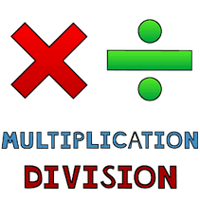
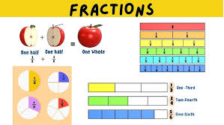
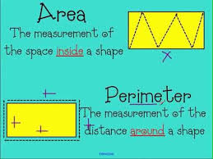
Maths – We will be exploring:
1. Multiplication and division
2. Fractions
3. Decimals and percentages
4. Perimeter and area
5. Statistics.

Science – In science, we will be learning about ‘Changes in Materials’. Children will learn to describe how to recover a substance from a solution; demonstrate that dissolving, mixing and changes of state are reversible changes; and finally, they learn how to explain that some changes result in the formation of new materials and that this kind of change is not usually reversible, including changes associated with burning and the action of acid on bicarbonate of soda.
History – In history, we will be learning about the Tudors.
P.E – Our PE unit this half term is going to be dance.
R.E. – The focus of our RE lessons this half term will be ‘Why do Christians believe that Jesus was the Messiah?’
ICT – We are going to be looking at computing systems and networks including search engines.

Spanish - We will be learning key phrases and vocabulary to describe the weather.
Music - This half term we will be learning to play the Ukulele.
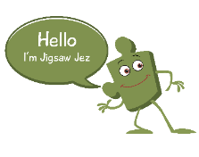
Jigsaw - In PSHE this half term our topic will be (Dreams and goals)
• Know that they will need money to help them to achieve some of their dreams • Know about a range of jobs that are carried out by people I know • Know that different jobs pay more money than others • Know the types of job they might like to do when they are older • Know that young people from different cultures may have different dreams and goals • Know that communicating with someone from a different culture means that they can learn from them and vice versa • Know ways that they can support
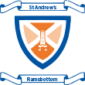
Year 5 Curriculum Newsletter spring 1

