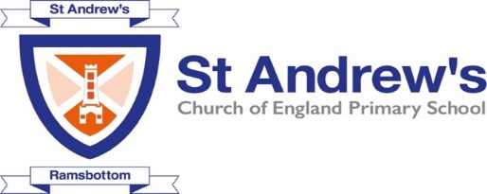
Curriculum Newsletter Autumn 1
Reception
Growth Mindset mantra | Believe you can and you are halfway there
This Half Terms Topic/Themes | This Half Term we are starting with “All About Me” as our topic, to give every child a chance to tell us about themselves and the things that are important to them.
Mathematics | - Name 2D shapes  - Continue, copy and create repeating patterns  - Count objects, actions and sounds  - Use positional language.  - Subertise quantities to 3.
Literacy | - Read individual letters by saying the sounds for them.  - Spell words by identifying the sounds and then writing the sound with letter/s.  - Able to use talk to link ideas.  - Write name by copying from a name card or memory.  - Write some initial sounds (linked to name)  - Orally segment CVC words e.g. c-a-t, p-i-n, b-o-g  - Can hear (phonemic awareness) and tune into initial sounds in words  - Consider pencil grip and dominate hand.  - Can draw lines and circles.  - Can write some recognisable letters from name.  - Can practise Phoneme Grapheme correspondence (PGC) by writing some Phase 2 sounds taught this term such as satp, inmd, gock, ck, eur, hbfl
Understanding the World | - Comment on images of familiar situations in the past.  - Know which food are healthy.  - Name a variety of fruits and vegetables.  - Know that they started life as a baby but have since grown and changed.  - Know that someone’s age is the time since they were born.  - Use some language for talking about the passing of time and events that have already happened (before, yesterday, last year).  - Begin to sequence events when describing them  - Recognise significant dates for them (birthday).  - Recount activities that happened in their past using photos as a prompt.
Physical | - Use their core muscle strength to achieve a good posture when sitting at a table or sitting on the floor.  - Further develop the skills they need to manage the school day successfully  - Develop their small motor skills so that they can use a range of tools competently, safely and confidently: pencils for drawing and writing, paintbrushes, scissors, knives, forks and spoons.  - Be able to complete a full Yoga circuit and be able to control their bodies when doing so.  - Learn about being active and the effects of exercise on their bodies.
Communication and Language | - Learn new vocabulary.  - Understand how to listen carefully and why listening is important.  - Engage in story times.  - Listen carefully to rhymes and songs, paying attention to how they sound.  - Develop social phrases.  - Understand and use question words such as when, where, what and why.  - Understand before and after to help them sequence events.  - Understand emotions from facial expressions.  - Learn to remember and say 5 things.  - To understand how to listen carefully and talk about what I hear.
Personal, Social and Emotional | - Identify and moderate their own feelings socially and emotionally.  - See themselves as a valuable individual  - Know they have a right to learn and play, safely and happily  - Know that some people are different from themselves  - Know that hands can be used kindly and unkindly  - Identify feelings associated with belonging  - Skills to play co-operatively with others  - Be able to consider others’ feelings
Expressive Art and Design | - Listen attentively, move to and talk about music, expressing their feelings and responses.  - Explore mark making using a range of drawing materials.  - Investigate marks and patterns when drawing.  - Identify similarities and difference between drawing tools.  - Investigate how to make large and small movements with control when drawing.  - Practise looking carefully when drawing.  - Combine materials when drawing.  - To know that sounds can be copied by my voice, body percussion and instruments.  - To understand that instruments can be played loudly or softly

