As a Pupil at Wellsprings School I will try to:

- arrive at school well rested, having had a good night’s sleep
- bring the things I need and look after them
- be proud to wear my school uniform and always try to look smart
- behave well, by being polite and helpful- follow the school’s golden rules
- show respect for the school, the staff and all the people around me
- help to take responsibility for the school and keep it free from litter
- do my best so I get the most out of each day

Signed ………………………………………

Pupil

As a Parent or Carer of a child at Wellsprings School, I/We will try to;

- see that my child comes to school on time, clean and tidy with all the equipment they need
- let the school know in a calm, supportive manner about any problems which may affect my child’s work, health, behaviour or attendance
- ensure support for my child with home learning activities including hearing them read regularly
- encourage my child to comply with the uniform code outlined in the school brochure
- attend parents’ meetings and discussions about my child’s progress
- work in partnership with the school in the best interest of my child

Signed ………………………………………………….

Parent/Guardian

The Staff at Wellsprings School will try to;

- be warm and welcoming
- treat you and your child with respect
- encourage your child to do their best at all times
- provide a safe environment where your child can learn happily
- help your child develop a sense of responsibility and consideration for others and their surroundings
- contact you promptly in a calm, supportive manner, about any concerns about your child
- provide an interesting curriculum for your child in and out of school hours
- work in partnership with parents and carers and other users of the school
- encourage and provide opportunities for life-long learning experiences
- listen to concerns and endeavour to help wherever possible

Signed …………………………………………
Chair of Governors

Signed ………………………………………
Headteacher
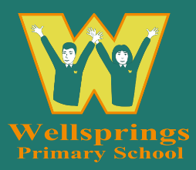

WELLSPRINGS SCHOOL

HOME/SCHOOL AGREEMENT
Refer to Wellsprings Behaviour and Relationships Policy and Complaints against the school Policy

Wellsprings School Vision statement
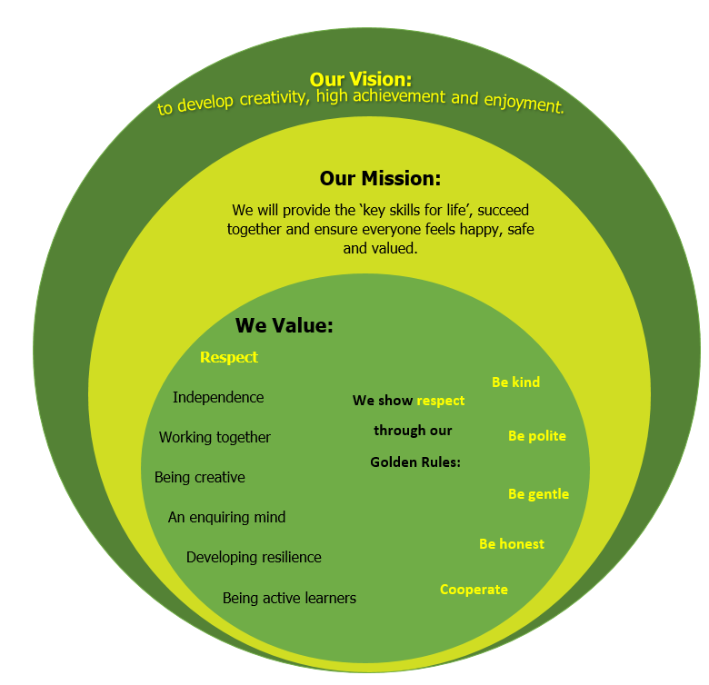

Name ……………………………………..

