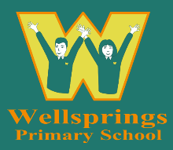
Wellsprings Primary School
Staff code of conduct
Summer 2026
Wellsprings School Vision statement
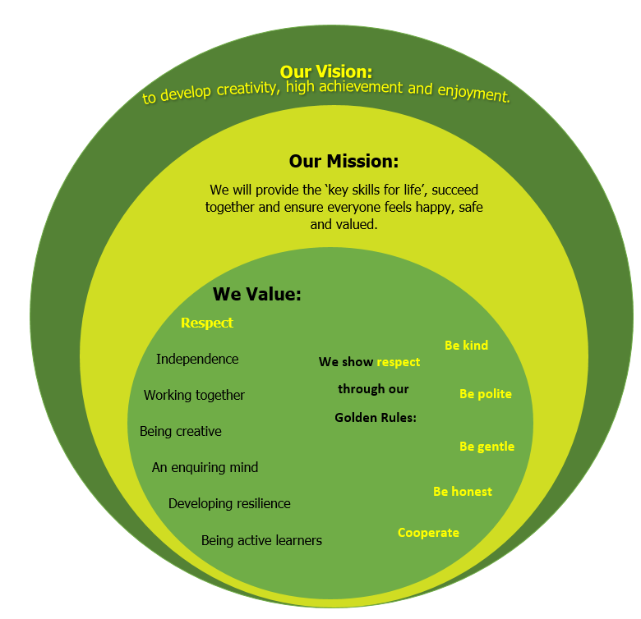

Contents
1. Aims, scope and principles 2
2. Legislation and guidance 2
3. General obligations 2
4. Safeguarding 3
5. Staff/pupil relationships 3
6. Communication and social media 3
7. Acceptable use of technology 4
8. Confidentiality 4
9. Honesty and integrity 4
10. Dress code 4
11. Conduct outside of work 4
12. Monitoring arrangements 5
13. Links with other policies 5

…………………………………………………………………………………………………………………………….

Aims, scope and principles
This policy aims to set and maintain standards of conduct that we expect all staff to follow.
By creating this policy, we aim to ensure our school is an environment where everyone is safe, happy and treated with respect.
Many of the principles in this code of conduct are based on the Teachers’ Standards.
School staff have an influential position in the school, and must act as role models for pupils by consistently demonstrating high standards of behaviour.
We expect that all staff will act in accordance with the personal and professional behaviours set out in the Teachers’ Standards.
We expect all support staff, governors and volunteers to also act with personal and professional integrity, respecting the safety and wellbeing of others.
Failure to follow the code of conduct may result in disciplinary action being taken, as set out in our staff disciplinary procedures.
Please note that this code of conduct is not exhaustive. If situations arise that are not covered by this code, staff must use their professional judgement and act in the best interests of the school and its pupils.

Legislation and guidance
We are required to set out a staff code of conduct under regulation 7 of The
School Staffing (England) Regulations 2009.
Conduct and discipline of staff
7.—(1) The governing body must establish procedures—
- for the regulation of the conduct and discipline of staff at the school; and
- by which staff may seek redress for any grievance relating to their work at the school.
In line with the statutory safeguarding guidance ‘Keeping children safe in education’, we should have a staff code of conduct, which should cover acceptable use of technologies, staff/pupil relationships and communications, including the use of social media.

General obligations
Staff set an example to pupils. They must:
- Maintain high standards in their attendance and punctuality
- Never use inappropriate or offensive language in school
- Treat pupils and others with dignity and respect
- Show tolerance and respect for the rights of others
- Not undermine fundamental British values, including democracy, the rule of law, individual liberty and mutual respect, and tolerance of those with different faiths and beliefs
- Express personal beliefs in a way that will not overly influence pupils, and will not exploit pupils’ vulnerability or might lead them to break the law
- Understand the statutory frameworks they must act within
- Adhere to the Teachers’ Standards

Safeguarding
Staff have a duty to safeguard pupils from harm, and to report any concerns they have. This includes physical, emotional and sexual abuse, or neglect.
Staff must familiarise themselves with our safeguarding policy and procedures and the Prevent initiative, and ensure they are aware of the processes to follow if they have concerns about a child.
Our safeguarding policy and procedures are available in the staff room, on the R Drive and from the school office. New staff will also be given copies on arrival. Staff should be aware of the school’s Safeguarding policy. https://www.wellsprings.somerset.sch.uk/page/policies/151333

Staff/pupil relationships
Staff must observe proper boundaries with pupils that are appropriate to the teacher’s and Staff’s professional position. They must act in a fair and transparent way that would not lead anyone to reasonably assume they are not doing so.
If staff members and pupils must spend time on a one-to-one basis, staff must ensure that:
- This takes place in a public place that others can access
- Others can see in to the room
- A colleague or line manager knows this is taking place
Staff should avoid contact with pupils outside of school hours if possible.
Personal contact details should not be exchanged between staff and pupils. This includes social media profiles, mobile phone numbers, phone numbers and addresses.
If a staff member is concerned at any point that an interaction between themselves and a pupil may be misinterpreted, this should be reported to their line manager or the headteacher.

Communication and social media
School staff’s social media profiles should not be available to pupils. If they have a personal profile on social media sites, they should not use their full name, as pupils may be able to find them. Staff should consider using a first and middle name instead, and set public profiles to private.
Staff should not attempt to contact pupils or their parents via social media, or any other means outside school, in order to develop any sort of relationship. They must not make any efforts to find pupils’ or parents’ social media profiles.
Staff should not attempt to contact pupils or their parents in any way outside of school.
Staff must ensure that they do not post any images online that identify children who are pupils at the school without their consent.
Staff should be aware of the school’s computing, acceptable use and Data Protection/FOIA policies. https://www.wellsprings.somerset.sch.uk/page/policies/151333

Acceptable use of technology
Staff must not use technology in school to view material that is illegal, inappropriate or likely to be deemed offensive. This includes, but is not limited to, sending obscene emails, gambling and viewing pornography or other inappropriate content.
Staff must also not use personal mobile phones or cameras to take pictures of pupils.
We have the right to monitor emails and internet use on the school IT system.
Staff should be aware of the school’s computing, acceptable use and Data Protection/FOIA policies. policy.

Confidentiality
In the course of their role, members of staff are often privy to sensitive and confidential information about the school, staff, pupils and their parents.
This information must never be:
- Disclosed to anyone without the relevant authority
- Used to humiliate, embarrass or blackmail others
- Used for a purpose other than what it was collected and intended for
This does not overrule staff’s duty to report child protection concerns to the appropriate channel where staff believe a child is at risk of harm.
Staff should be aware of the school’s Safeguarding policy and the GDPR policy. https://www.wellsprings.somerset.sch.uk/page/policies/151333

Honesty and integrity
Staff should maintain high standards of honesty and integrity in their role. This includes when dealing with pupils, handling money, claiming expenses and using school property and facilities.
Staff must not accept bribes. Gifts that are worth more than £15 must be declared and recorded on the gifts and hospitality register.
Staff must ensure that all information given to the school about their qualifications and professional experience is correct.

Dress code
Staff must dress in a professional, appropriate manner.
Outfits must not be overly revealing, and we ask that tattoos are covered up wherever possible.
Clothes must not display any offensive or political slogans.

Conduct outside of work
Staff must not act in a way that would bring the school or the teaching profession into disrepute. This covers relevant criminal offences, such as violence or sexual misconduct, as well as negative comments about the school on social media.

Monitoring arrangements
This policy will be reviewed every year, but can be revised as needed.

Links with other policies
Staff should be aware of the school’s policies by visiting the policy section on our school website: https://www.wellsprings.somerset.sch.uk/page/policies/151333

