Year: 1 Term: Spring Teaching focus: Formal elements: Texture, Movement, Colour Artist: Franz Marc Formal elements- Colour, tone, line, shape, pattern
Prior learning : |  |  |  |  | Prior vocabulary:
Reception- Artist: Andy Goldsworthy and Kandinsky  Select thick and thin brushes for a purpose. Select colours for a purpose and begin to mix these colours eg orange, green and purple. |  |  |  |  | colours, mix, easel, artist
New key vocabulary (taken from Subject teams documentation): |  |  |  | Images/Pictures/Diagrams/Maps:
Primary Colours |  | Red, yellow and blue |  | 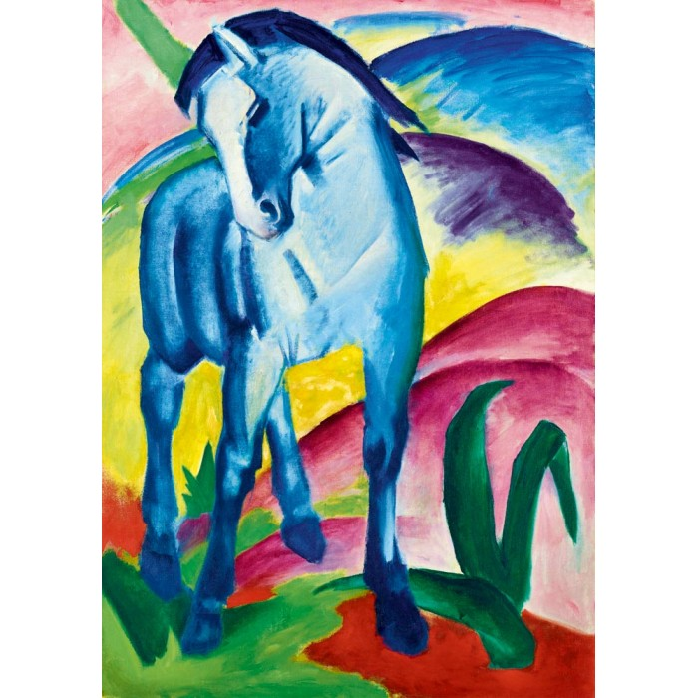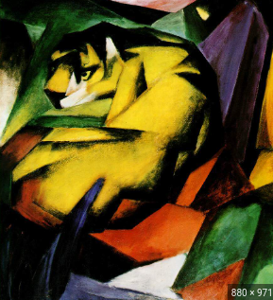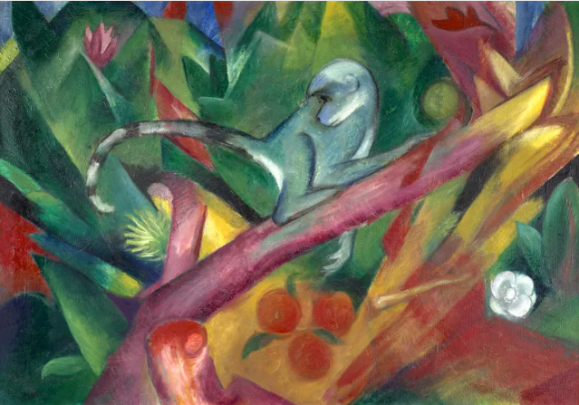  Taking inspiration from artists like; Franz Marc (contemporary.)
Secondary Colours |  | Colours that can be made by mixing any two primary colours
Paint techniques |  | Stroke, dab, spread, layer, splas, mix, drip, dribble.  Wax resist - wax stops the paint from sticking to the paper.
Drawing techniques |  | Line, dot, scribble, doodle, pattern, sketch.
Key Knowledge/ Key skills (in teaching order with corresponding subject specific skills) |  |  |  | Key Skills:
1. | Generate ideas from stimuli.  Identify key visual elements of medium: line/dot, tone, colour, pattern  What different lines has the artist used? Look at artworks from the artist and discuss the following questions: How does this artwork make you feel? What do the colours remind you of? |  |  | 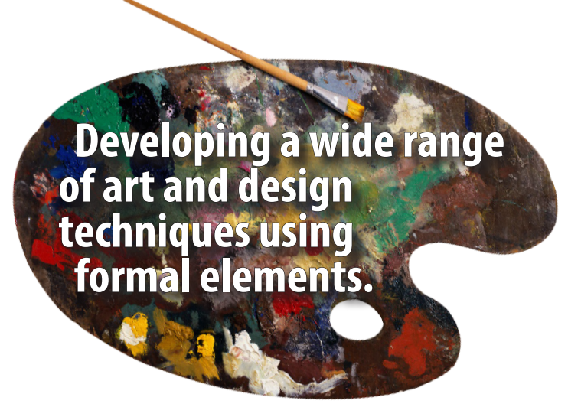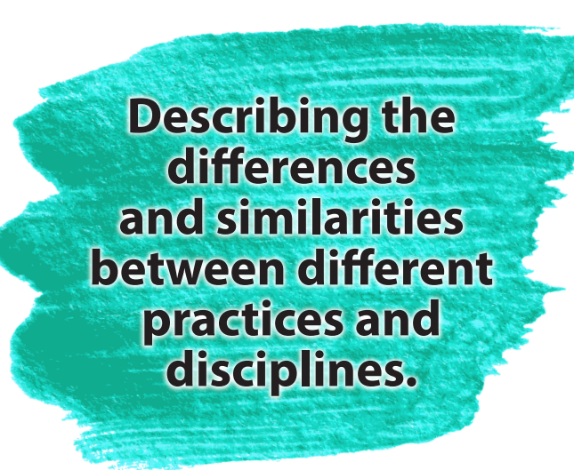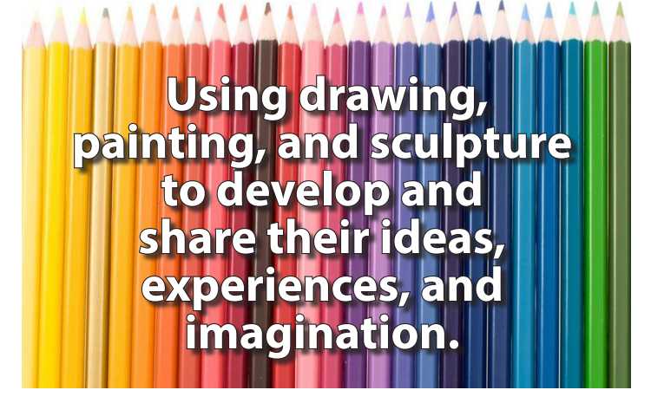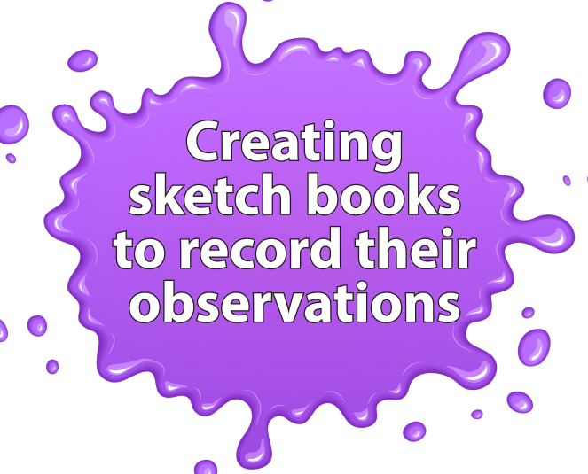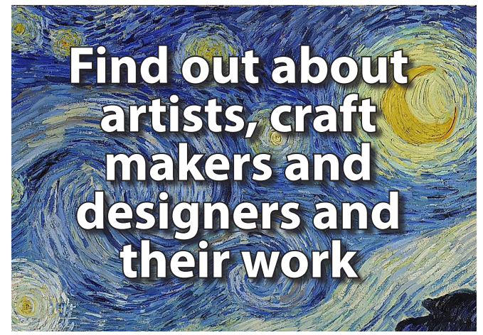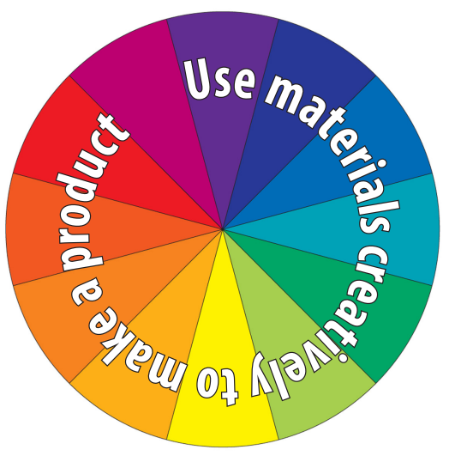
2. | Identify and experiment with line/dot/scribble/doodle/pattern mark making of different sizes/types and colours. Fill in solid shapes if desired.
3. | Name primary and secondary colours. Explore mixing primary colours to make secondary colours. Make paint marks of different sizes/types/colours on various surfaces with various tools.
4. | Experiment: stroke, dab, spread, layer, splash, mix, drip, dribble.  Use: brush, finger, stick, sponge, spray, spatula, card strips to apply paint.  Use: brush, finger, stick, sponge, spray, spatula, card strips to apply paint.  Use wax crayon to resist paint.
5 | Ongoing - Create an individual piece of art; practicing and applying key skills..  Peer review work and make links between work

