Year: One Term: Spring 2 Teaching focus: Biology - Humans
Prior learning : |  |  |  |  | Prior vocabulary:
Basic body parts  Sens#es walk- Linked to Seasons. |  |  |  |  | Head, nose, mouth, teeth, ear, arm, hand, back, leg, knee, ankle, foot.  Sight, sound, touch, smell, taste.
New key vocabulary (taken from Subject teams documentation): |  |  |  | Images/Pictures/Diagrams/Maps:
Compare |  | To look for things that are the same and different. |  | 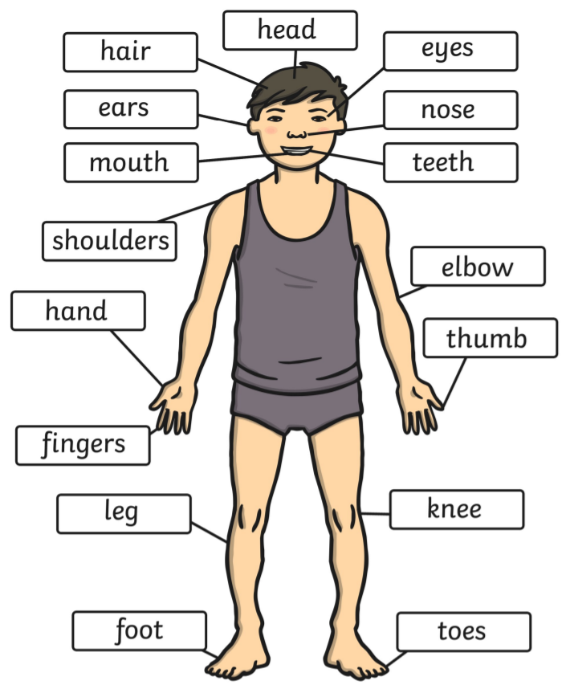  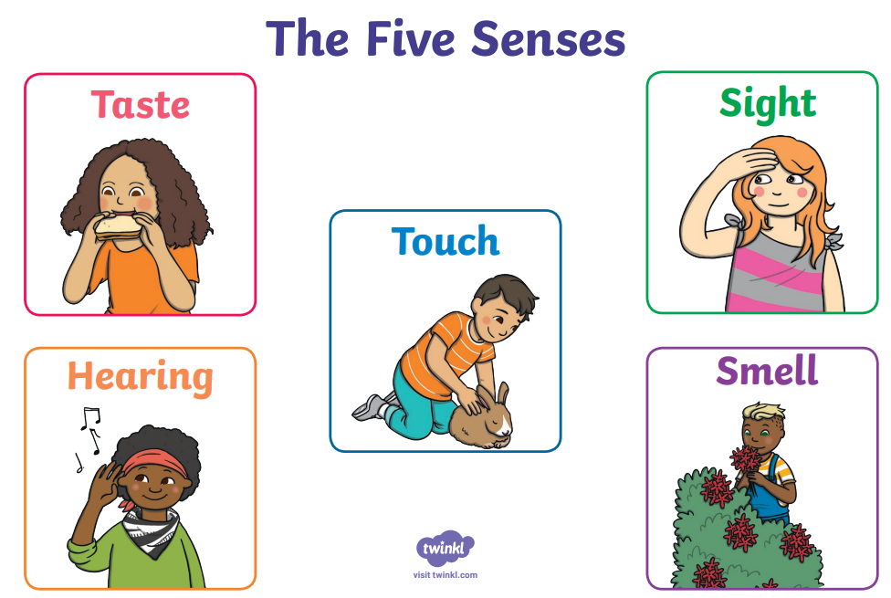
Table |  | To clearly present information that I have found.
Diagram |  | To draw a picture and label it.
Fair test |  | When only one variable is changed at a time.
Results |  | What you find out from the investigation.
Measure |  | To find the size or amount of something.
Key Knowledge (in teaching order with corresponding subject specific skills) |  |  |  | Key Skills: |  | Scientific Enquiry type:
1. | I can use basic scientific vocabulary to label the human body.  I can make first-hand close observations of parts of the body, eg, eyes, hands and record using drawings.  Additional vocabulary: wrist, elbow, shoulder, neck, ankle, hip, chest, fingers, finger nails, thumb, teeth, tongue, nostrils, eye lashes, eye brows. |  |  | 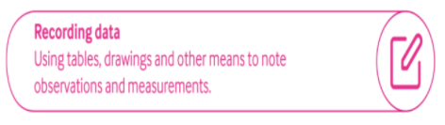  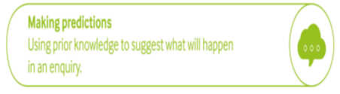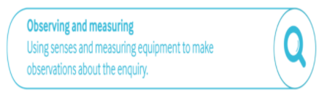  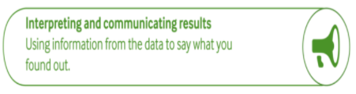  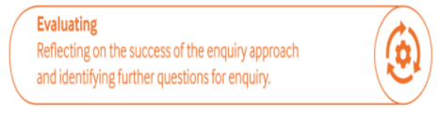 |  | 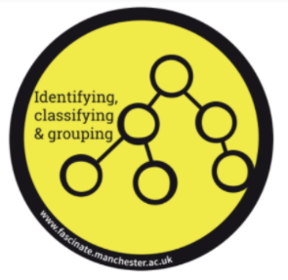  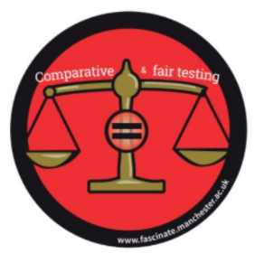  
2. | Look for patterns between people. Do people with big hands have big feet?
3. | Humans need a variety of food to help them grow and stay healthy.  What is in my healthy lunchbox?
4. | Humans have 5 senses; e.g. mouth to taste and ears to listen.  Popcorn investigation - I can hear/ smell/ see/ feel/ taste…
5. | Link body parts to senses through practical investigations.  Which part of the body is good for feeling? Which is not?  Which smells can I match?  Which flavors can I identify by taste?  I can investigate and answer questions using my senses.

Year: One Term: Spring 2 Teaching focus: Humans
Post Learning:

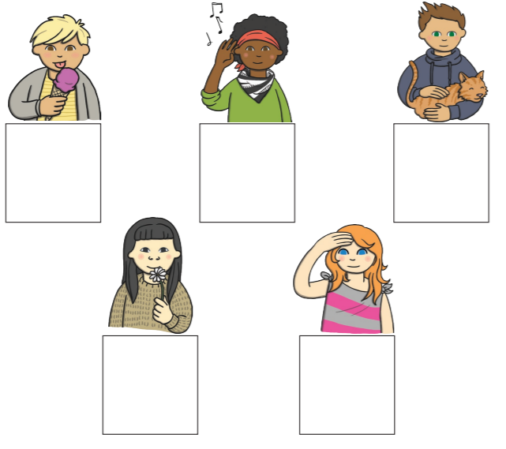
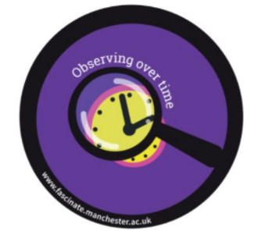
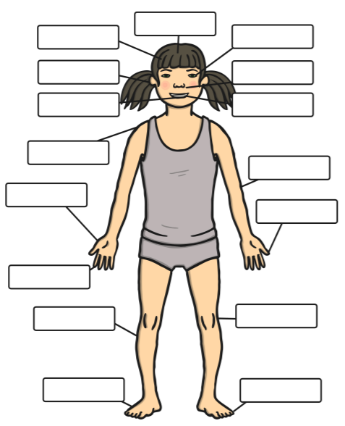
Which enquiry types have we used this half term?

