Year: One Term: Autumn 2 Teaching focus: Biology - Animals
Prior learning : |  |  |  | Prior vocabulary:
In EYFS children had opportunities to name familiar animals; farm animals; zoo animals; minibeasts etc.  Children have looked at habitats and caring for animals. |  |  |  | Animal names  Habitats
New key vocabulary (taken from Subject teams documentation): |  |  |  | Images/Pictures/Diagrams/Maps:
Fish |  | Fish live in water, breathe with gills, and usually have fins and scales. |  | 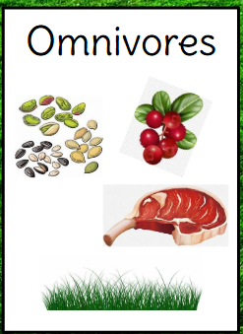  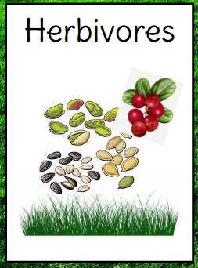  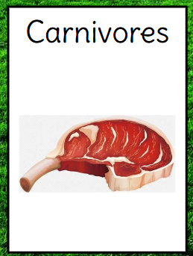  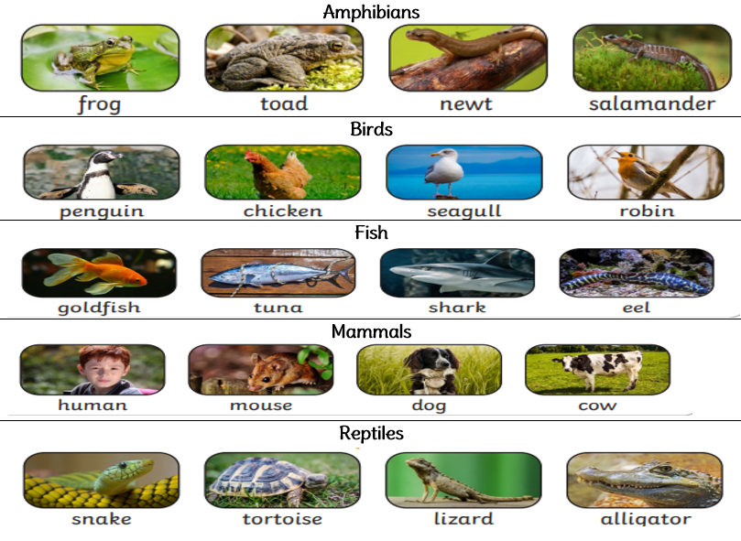
Reptile |  | Air-breathing animal that has scales instead of hair or feathers.
Mammal |  | Have fur or hair and give birth to young.
Bird |  | Have feathers and wings; lay eggs and are warm blooded.
Amphibian |  | Live on land and in water; cold blooded; moist skin and webbed feet.
Herbivore |  | Animals that eat plants.
Carnivore |  | Animals that eat meat.
Omnivore |  | Animals that eat plants and animals.
Key Knowledge (in teaching order with corresponding subject specific skills) |  |  |  | Key Skills: |  | Scientific Enquiry type:
1. | There are lots of different types of creatures in the world. E.g. Fish, birds |  |  | To sort animals based on their physical characteristics and our prior knowledge of them.  To identify and name a variety of common animals.  To sort animals into groups; fish; birds etc. |  | 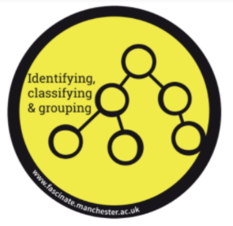
2. | Animals look different eg. birds have wings, fish have scales. |  |  | To sort animals based on their physical characteristics and our prior knowledge of them.
3. | Animals eat different types of foods e.g. carnivores eat meat, omnivores eat meat and plants, herbivores eat plants.  Investigate animal poop to identify a herbivore, omnivore and carnivore based on their diets. |  |  | Observe and complete a simple test to find out what different food animals eat.  Explain what we have found out using scientific language.

Year: One Term: Autumn 2 Teaching focus: Animals
Post Learning:
Draw and label an animal including its different parts. .


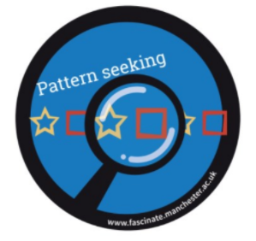
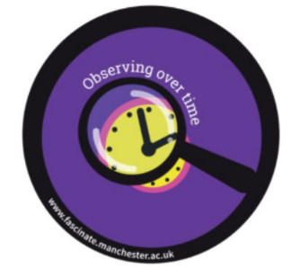
Which enquiry types have we used this half term?

