Year: 1 Term: Spring Teaching focus: Societal Change - Power - Who is King Charles III and what does he do? Who was Queen Elizabeth II? (1952 - 2022)
Prior learning : |  |  |  |  | Prior vocabulary:
Year 1 Building on  Use pictures (sources) to find out about our school in the past.  Know about significant places in my own locality- our school  Place 3 events on a timeline 1998 - 2022  Use pictures (sources) to find out about Ellesmere Port in the past (1998)  Use pictures to compare Ellesmere Port in 1998 to the present. |  |  |  |  | past | Something that has already happened
 |  |  |  |  | present | What is happening now
 |  |  |  |  | timeline | A way of putting pictures or things that happened in order
New key vocabulary (taken from Subject teams documentation): |  |  |  | Images/Pictures/Diagrams/Maps:
Monarch |  | Someone who rules a country - a King or a Queen |  | 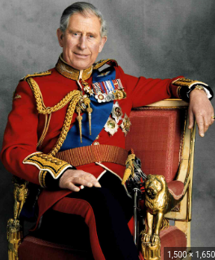  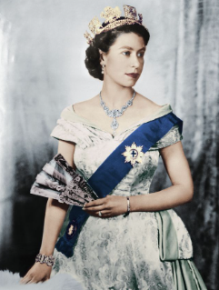
Queen |  | A female ruler
King |  | A male ruler
reign |  | The amount of time a King or Queen is in charge for
coronation |  | Where lots of people come to see a King or Queen being given their crown
jubilee |  | A celebration that happens after a King or Queen has been the ruler for a certain time (25 years, 50 years, 60 years and 70 years)
Royal family |  | The family of the King or Queen |  | Queen Elizabeth II King Charles III
Key Knowledge (in teaching order ) |  |  |  | Key Skills:
1. | Queen Elizabeth reigned for 70 years. |  |  | Use pictures (sources) to find out about Queen Elizabeth II.  Put 3 pictures of Queen Elizabeth in order on a timeline.  Talk about why/ what/ how events happened  Talk about why Charles became King  Talk about what I found out.
2. | Queen Elizabeth died in 2022.
3. | Charles became King in 2022.
4. | King Charles has 2 sons. Prince William will become King next.  Prince William has 3 children.
5. | King Charles rules the UK and the Commonwealth.

Year: 1 Term: Spring Teaching focus: Societal Change - Empires Who is King Charles III and what does he do?
Who was Queen Elizabeth II? (1952 - 2022)
Post Learning / Post Vocabulary

______________________________________________ | _______________________________________________
___________________________________________________________  ___________________________________________________________  ___________________________________________________________  ___________________________________________________________ | ___________________________________________________________  ___________________________________________________________  ___________________________________________________________  ___________________________________________________________

