Year: 1 Term: Spring Term Teaching focus: Place - What is the UK made up of?
Prior learning : |  |  |  |  |  | Prior vocabulary:
Reception- I live in Ellesmere Port. Naming features in our local town. Following simple instructions to follow a simple route.  Year 1 - Locate the school, field and playground on an aerial map. Create a simple map using pictures or symbols. Local area- Ellesmere Port. |  |  |  |  |  | Street, railway, road, church, playground, map, school, compass, Ellesmere Port
New key vocabulary (taken from Subject teams documentation): |  |  |  |  | Images/Pictures/Diagrams/Maps:
United Kingdom |  | The UK is where we live. |  |  | 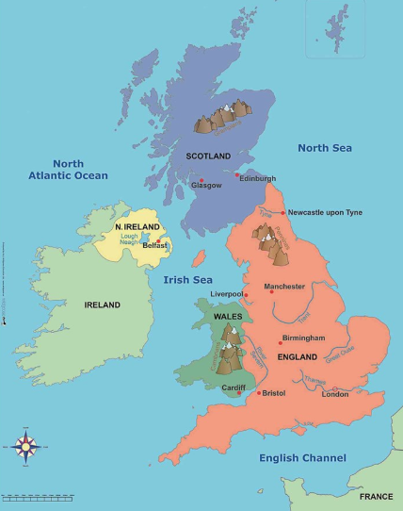
London |  | Capital city of England.
Cardiff |  | Capital city of Wales
Edinburgh |  | Capital city of Scotland
Belfast |  | Capital city of Northern Ireland
River Thames |  | A river in London
Compass |  | Direction: North, South, East, West
Key Knowledge (in teaching order with corresponding subject specific skills) |  |  |  |  | Key Skills:
1. | Fieldwork- To recognise 4 compass directions. What features can you see in a given direction from different points of our school grounds? |  |  |  | Recognise compass points (NSEW)  Name and locate the four countries of the UK on a simple map.  Identify where we live on a map of the UK.  Make simple observations of places.  Use aerial photographs to find key landmarks.  Identify 2-3 key man-made and natural features of an area.  Use simple local and world maps and introduce OS maps.
2. | To locate where we live on a map of the UK.
3. | Name and locate 4 countries on a map of the UK.
4. | Name and locate the capital cities in the UK.
5. | Name physical and human features in each capital city.  Physical features: London - River Thames; Cardiff - Bristol Channel; Edinburgh - Calton Hill; Belfast - River Lagan  Human features: London - London Eye; Cardiff - Principality Stadium; Edinburgh - Edinburgh Castle; Belfast - Belfast City Hall

Year: 1 Term: Spring Term Teaching focus: What is the weather like in the UK?
Post Learning:

