Year: 1 Term: Spring 1 Teaching focus: How do people with similar or different worldviews believe the world
began and how should we look after it?
Prior learning : |  |  |  |  | Prior vocabulary:
Reception- Chn have talked about the Christian creation story and how we look after our world. E.g. We need to look after our world by putting rubbish in the bin. We need to look after our world by recycling rubbish. |  |  |  |  | World, Beginning
New key vocabulary (taken from Subject teams documentation): |  |  |  | Images/Pictures/Diagrams/Maps:
God |  | Christians believe that he created the world. He is a special person. |  | 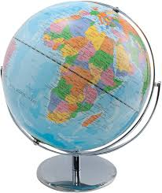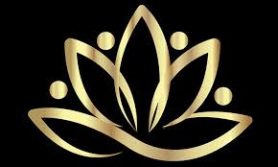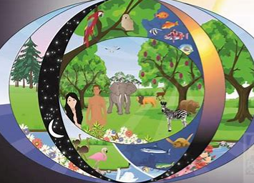
Creation |  | Christians believe that God created the world.
Stewardship |  | To look after the world.
Key Knowledge (in teaching order with corresponding subject specific skills) |  |  |  | Key Skills:
1. | Explain how Christians view the creation of the world and try to take care of it (stewardship). |  |  | 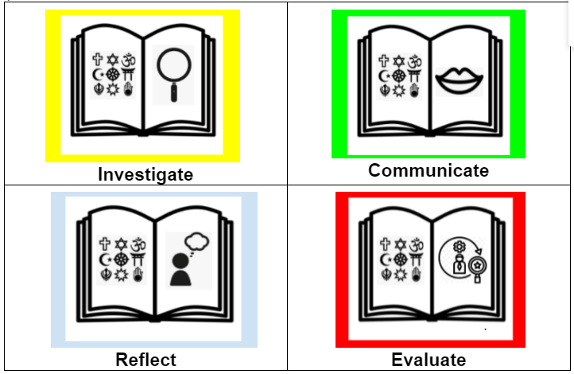
2. | Retell two stories that explain how the world was made.  (Christian Creation story/ Hindu Creation story)
3. | Explain how different groups of people believe the world was made.  (Hindu, Genesis, Big Bang Theory.)
4. | Describe how religious and non-religious people say we should care for the world (St Francis, David Attenborough).

