Year: 1 Term: Spring 1 and 2 Teaching focus: DT - Food and Nutrition - Preparing Fruit and vegetables
Fruit Kebab
Prior learning : |  |  |  |  | Prior vocabulary:
Children have participated in simple baking activities led by an adult in Reception. |  |  |  |  | design | Draw a picture of what you want something to look like and label it.
 |  |  |  |  | tools | Equipment that can be used to shape and fix different materials
 |  |  |  |  | make | Combine things together following a design
New key vocabulary (taken from Subject teams documentation): |  |  |  | Images/Pictures/Diagrams/Maps:
grate |  | reduce (food) to small shreds by rubbing it on a grater |  | 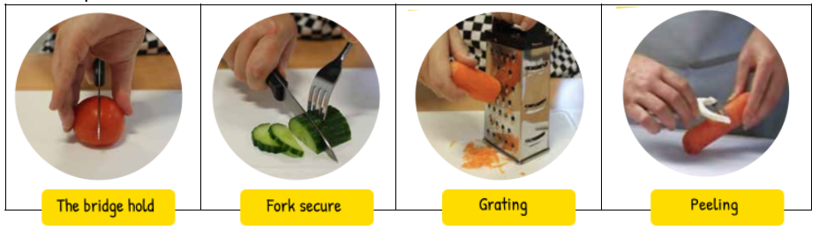  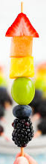  kebab
peel |  | remove the outer covering or skin from (a fruit or vegetable)
cut/chop |  | a method for cutting food into bite-sized pieces
spread |  | foods that are applied, generally with a knife, onto bread, crackers and similar foods
Healthy diet |  | Eating a variety of healthy foods including 5 portions of fruit and vegetables each day.
Key Knowledge (in teaching order with corresponding subject specific skills) |  |  |  | Key Skills:
1. | We should eat 5 portions of fruit and vegetables a day to stay healthy. |  |  | To use a knife safely to spread butter onto toast and cut the toast in half using the bridge hold method.  Select ingredients to make a healthy and tasty wrap.  Use a peeler and a grater safely.  Prepare and make a fruit kebab.  Place fruit safely and carefully on a skewer.  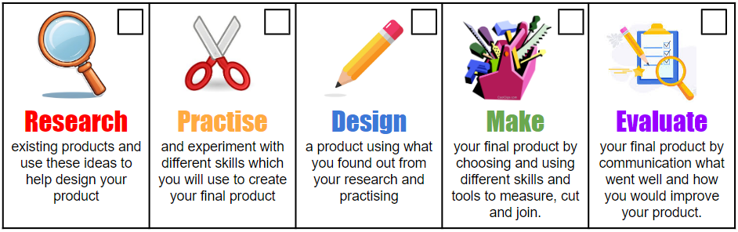
2. | Fruit and vegetables can be grown from plants or in the ground.
3. | Trying different foods is important.
4. | Make a healthy fruit kebab.  Use kitchen equipment safely.

