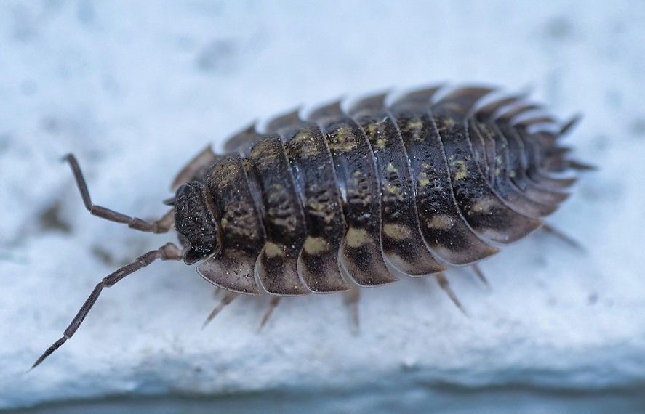
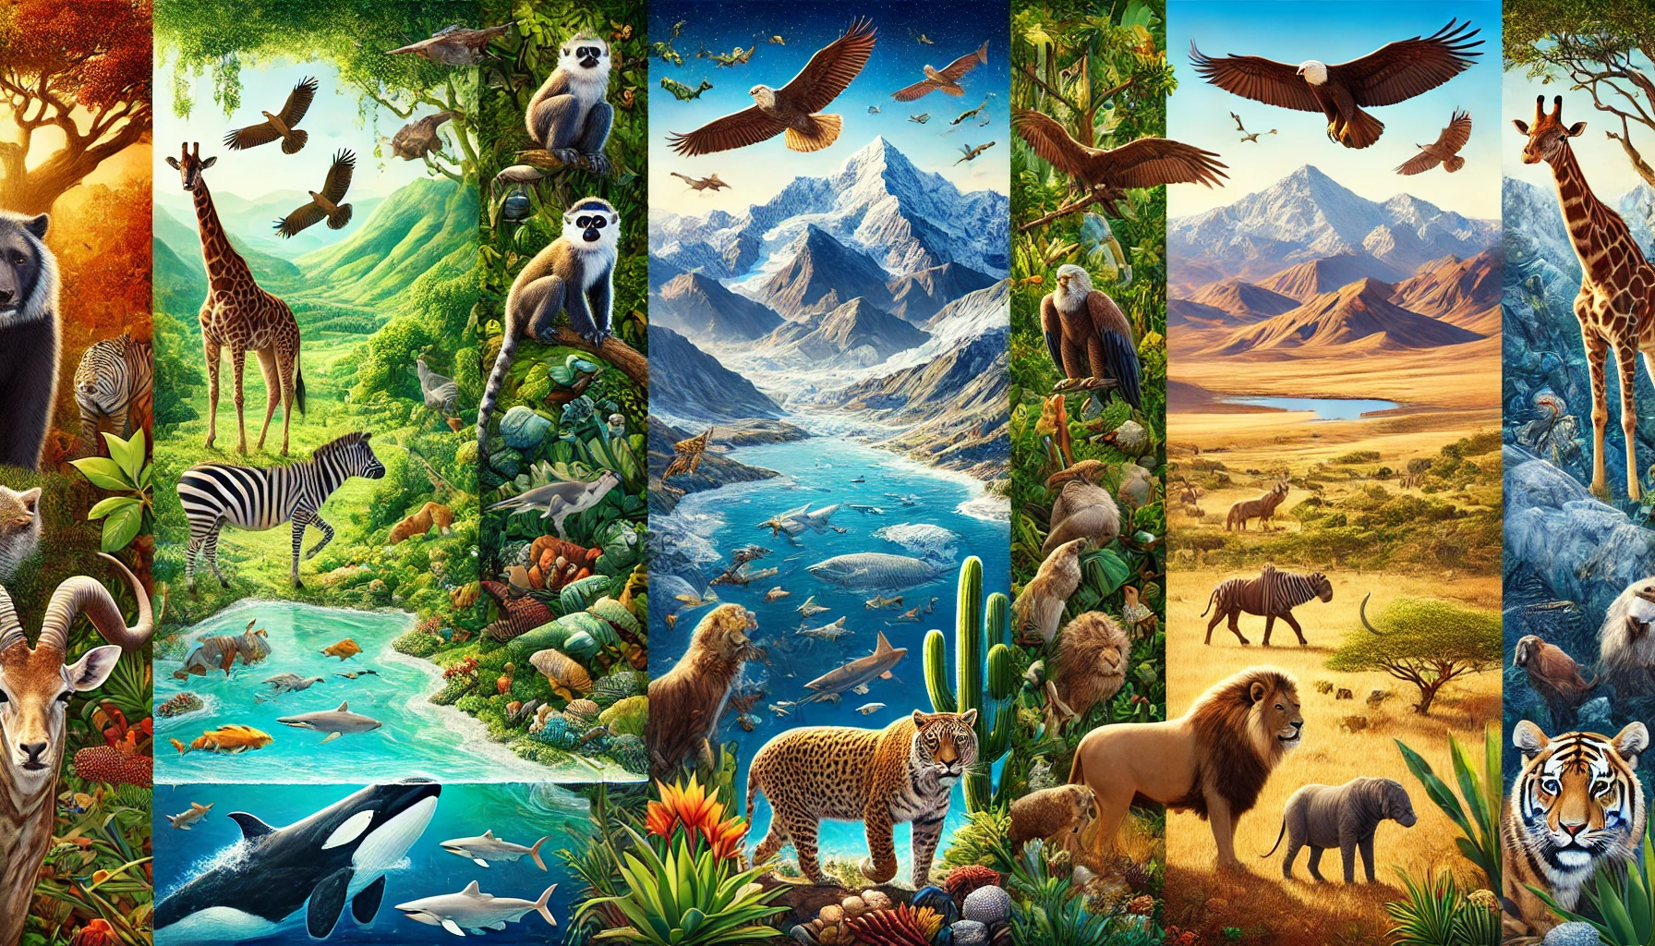



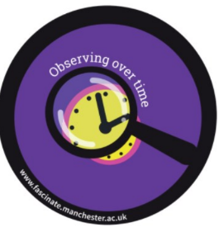

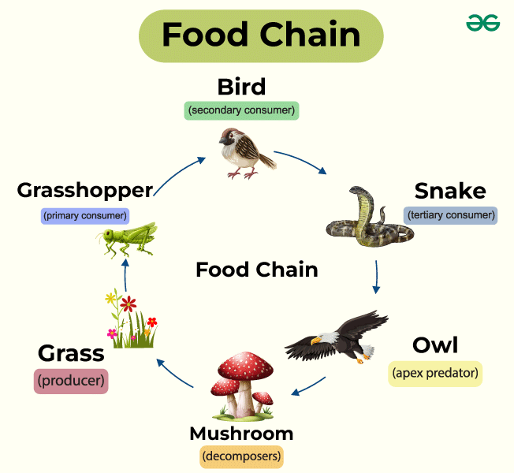
Year: 2 Term: Spring Teaching focus: Living things and their habitats
What is the most suitable habitat for a woodlouse?
Prior learning |  |  |  |  | Prior vocabulary:
Humans need a variety of food to help them grow and stay healthy.  Animals eat different types of foods eg carnivores eat meat, omnivores eat meat and plants, herbivores eat plants.  All animals have offspring -  cow:__________ dog:__________ cat:__________ duck:__________ sheep:__________ |  |  |  |  | Herbivore  Carnivore  Omnivore | Eat plants.  Eat meat.  Eat meat and plants.
 |  |  |  |  | Offspring | The baby of a plant or animal
 |  |  |  |  | Reproduce | When living things make a new living thing of the same kind.
 |  |  |  |  | Life cycle | The different stages of life for a living thing
New key vocabulary (taken from Subject teams documentation): |  |  |  | Images/Pictures/Diagrams/Maps:
Living |  | Things that are alive - they can grow, breathe, eat, move and reproduce.
Dead |  | Things that were once alive but are now dead.
Habitat |  | Where a living thing (animals or plants) live. They can get what they need to survive here.
Microhabitat |  | A small place within a habitat where small living things live.
Key Knowledge (in teaching order with corresponding subject specific skills) |  |  |  | Key Skills: |  |  |  | Scientific Enquiry type:
1. | Animals move in order to survive.  Exercise keeps animal’s bodies in good condition and increases survival chances. |  |  | Ask simple questions and know that they can be answered/investigated in different ways.  Research secondary sources, such as books and video clips.  Begin to make predictions about what might happen in an investigation linking to what they already know.  Observe closely and describe changes over time using their senses  Begin to describe how things have changed over time.  Record the results through annotated drawings or simple observation tables.  Use a ruler and a sand timer to carry out simple tests.  Use a stopwatch accurately.  Group materials, living things and objects, noticing changes over time and beginning to see patterns.  Begin to understand that to complete a fair test only one variable can change.  Gather data and record findings in a range of ways e.g. tally chart, Venn diagram, pictogram.
2. | All animals eventually die.
3. | Animals have young when they reach maturity.
4. | Animals get their food from plants and other animals.  Animals have different sources of food.
5. | A food chain explains what animals feed on.

