Year: 2 Term: Spring Teaching focus: Geography-What makes our world wonderful?
Prior learning : |  |  |  |  | Prior vocabulary:
In Year 1 the children named and located Europe and Asia and their surrounding oceans - the Atlantic and Pacific ocean. They identified the human and physical features of Ellesmere Port and Shanghai. |  |  |  |  | Ocean | An ocean is a huge body of salt water.
 |  |  |  |  | Capital city | A capital city is where the government of that country is based and some of the country's most iconic buildings can be found.
New key vocabulary (taken from Subject teams documentation): |  |  |  | Images/Pictures/Diagrams/Maps:
Landmark |  | Landmarks are features or structures around the world that are easily recognised or unique. |  | 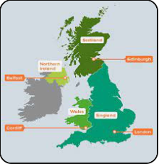  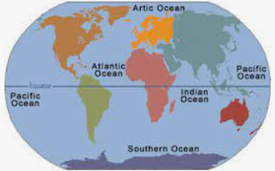
Map Key |  | A key is a guide which explains what the symbols on the map mean.
Aerial photograph |  | A photograph taken from the air.
Key Knowledge (in teaching order with corresponding subject specific skills) |  |  |  | Key Skills:
1. | To locate the four capital cities of the UK, London, Cardiff, Belfast & Edinburgh |  |  | Use maps, atlases and aerial photographs
2. | To identify human and physical features of capital cities in the UK |  |  | Locate and name places, present geographic information. Identify human and physical features.
3. | Use locational language (North, South, East, West) to describe the locations of cities on a map. |  |  | Use maps, atlases and globes. Use locational and directional language.
4. | To locate and name the 5 Oceans, Pacific, Atlantic, Indian, Southern and Arctic. |  |  | Use a world map. Identify physical and human features
5. | To compare and contrast the human and physical of Ellesmere Port and Burwardsley. |  |  | Identify human and physical features. Compare and contrast people and places.
6. | To use symbols on a sketch drawing of our school and Burwardsley. |  |  | Use maps, atlases and aerial photographs

