Year: 2 Term: Spring 1 Teaching focus: History - What were the consequences of The Great Fire of London?
Societal change
Prior learning : |  |  |  |  | Prior vocabulary:
What famous people or events from the past can you remember?  ______________________________________________________________________________ |  |  |  |  | Century | A period of 100 years
 |  |  |  |  | Time-line | The order in which events happened in history
New key vocabulary (taken from Subject teams documentation): |  |  |  | Images/Pictures/Diagrams/Maps:
congested |  | Crowded by people and prevents movement |  | 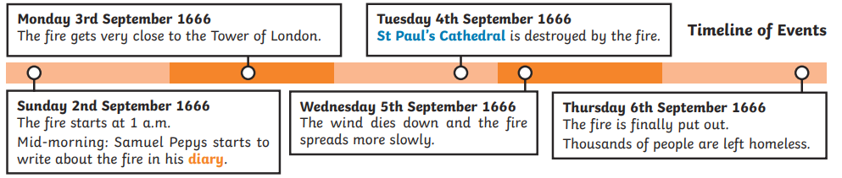
flammable |  | Easily set on fire
eye-witness |  | A person who has seen something happen and can give a first hand experience
consequence |  | What happens immediately after a behaviour
cause |  | A reason for an action or condition
Key Knowledge (in teaching order with corresponding subject specific skills) |  |  |  | Key Skills:
1. | The Great Fire of London started on Pudding lane in 1966. |  |  | Being curious. Asking questions.
2. | Buildings were made of wood. Windy conditions meant the fire spread quickly. |  |  | Being curious. Asking questions.
3. | Water did not put the fire out so King Charles II pulled down buildings to stop the fire from spreading further. |  |  | Examining how and why things have changed. Asking questions. Being curious.
4. | Samuel Pepys kept a diary about the fire. |  |  | Using evidence to explain the past
5. | Sir Christopher Wren rebuilt the City of London after the fire. |  |  | Examining how and why things have changed. Asking questions. Being curious.
6. | To create a time-line of events during the Great Fire of London. |  |  | Developing chronological knowledge

