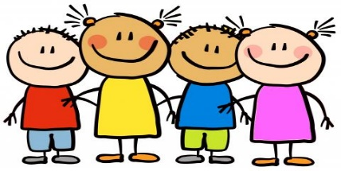**I Am Special!**

**Autumn 1**

Our Literacy Texts this half term will be:

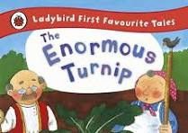 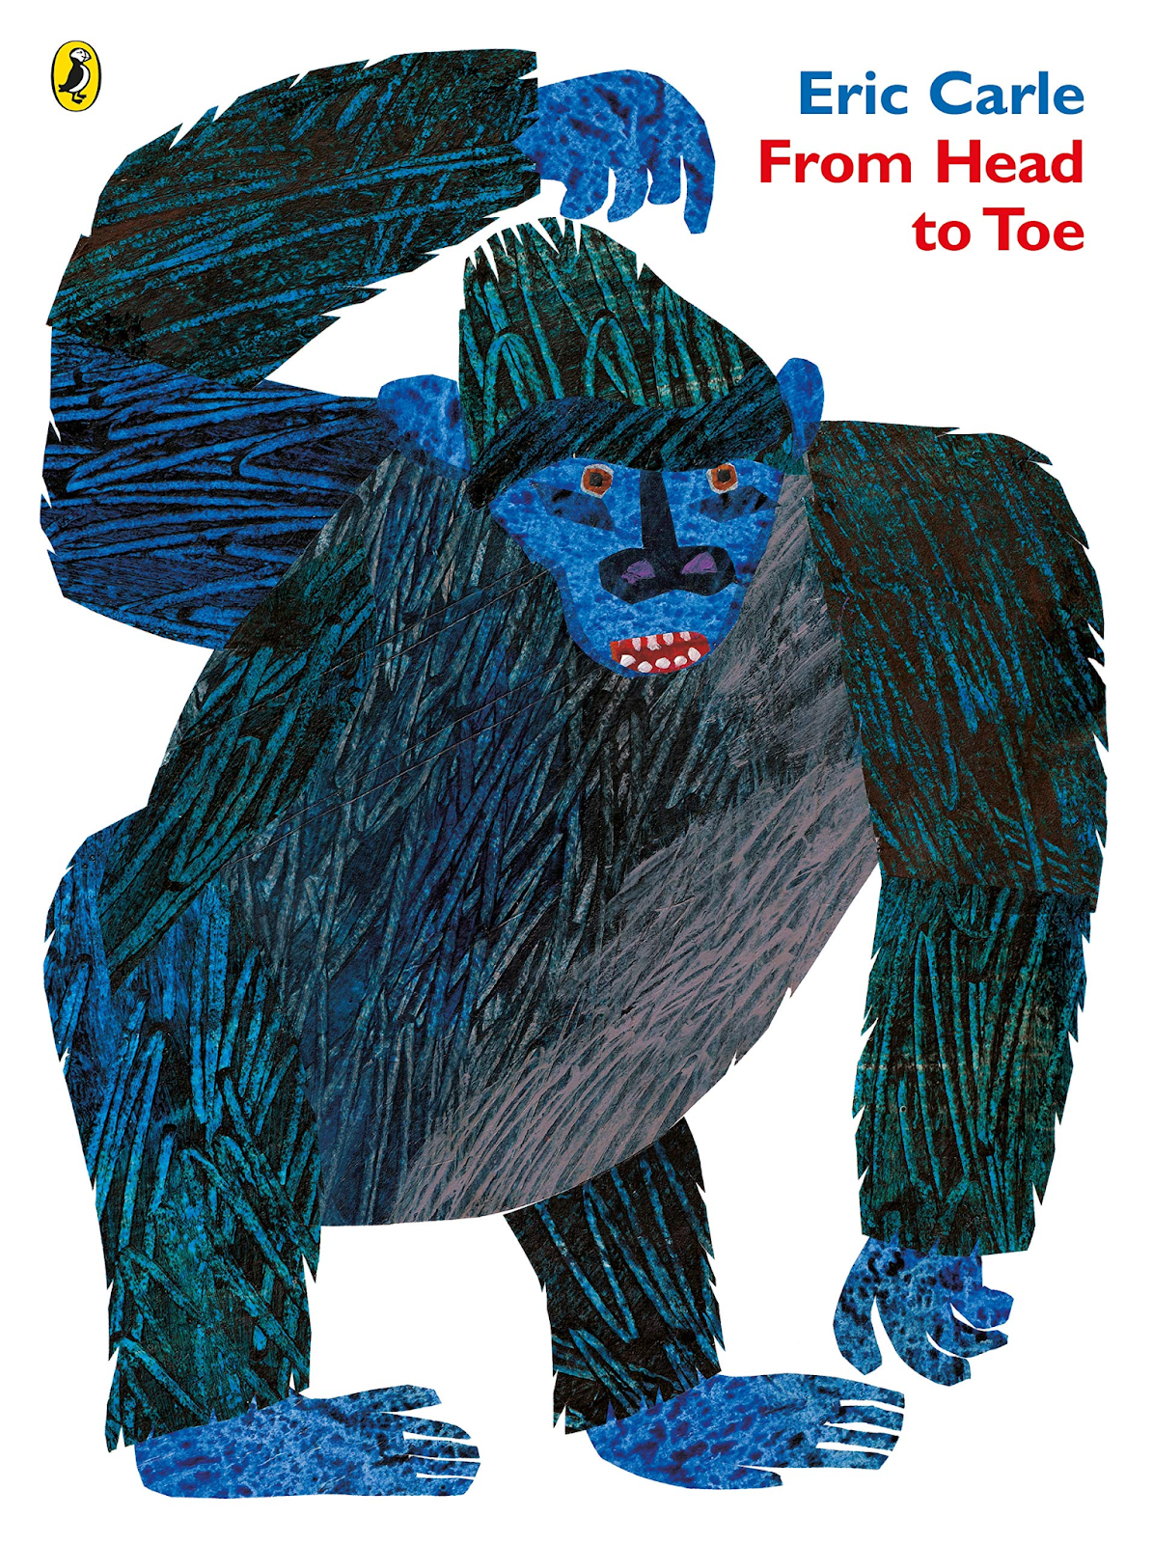 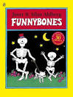 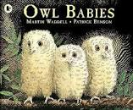 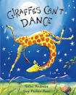

We will share lots of stories and poems in our daily storytime and will enjoy singing lots of songs and nursery

**Phonics:**

**The children will be playing listening and attention games and tuning into sounds as part of our Little Wandle Foundation for Phonics Scheme.**

**Our Nursery Rhymes**

Baa, Baa Black Sheep

If you’re Happy and You Know It

I’m a Little Teapot

Head, Shoulders, Knees & Toes

Twinkle, Twinkle Little Star

76

**Significant Events & Experiences:**

European Day of Languages

EYFS Open Day

Harvest Stay & Craft:

**Maths:**

This half term we will:

Sing number rhymes

Use of fingers to represent

numbers

Daily counting to 10 and back

Numbers 1 and 2

Explore shapes in the environment

|  |  |  |
| --- | --- | --- |
| **Area of Learning** | **Sticky Learning Words** | **Our New Skills** |
| Cartoon House Stock Illustrations – 306,270 Cartoon House Stock  Illustrations, Vectors & Clipart - DreamstimeHistory | Family, home, school, house, road | I will be able to talk about the people who are special to me  I will learn to retell special events and experiences |
| 소년 미소 얼굴 미소 미소 아이 아이 만화 몸 벡터 일러스트 절연 로열티 무료 사진, 그림, 이미지 그리고 스톡포토그래피. Image  61379426.Science | my body, head, shoulders, knees, toes, | I will explore a variety of materials  I will learn to name body parts |
| Cartoon family portrait Royalty Free Vector ImageR.E. | Family, Mum, Dad, sister, brother, Aunty, uncle, grandparent | I will learn to talk to my teacher and friends about who and what is special to me |
| Child Using A Wall To Draw A Selfportrait Stock Illustration - Download  Image Now - iStockArt | apron paintbrush, colour, space | I will learn to draw a self-portrait  I will give meaning to all of my drawings  I will be introduced to the work of artists |
| Cartoon Kids Baking Cookies/eps Stock Vector - Illustration of comics,  baker: 18973804DT | Chop, mix, stir, spread | I will learn to bake  I will learn to use equipment for baking |
| Computing  IPad 4 iPad Mini 4 iPad Air 2 Apple iPad Pro, Ipad cartoon, electronics,  gadget png | PNGEgg | Buttons, turn, press, on, off | I will learn the rules when using the smartboard and ipad  I will explore how things work |

**Music:**

We will explore sounds, songs and nursery rhymes

**PE:**

We shall be learning how to take our shoes and socks off for PE.

We will learn how to stay safe in the hall.

**PHSE:**

We will learn all about nursery’s Golden rules and our daily Routines