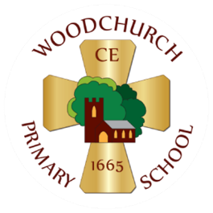

At Woodchurch CE Primary School, we strictly adhere to the new EYFS statutory framework (effective 01 September 2025) by:
- Children in F2 taking part in Snack and Chat twice a day. Fruit will be cut up into bite-sized pieces to prevent instances of choking. Children will be seated throughout this social session and supervised by an adult who holds a current Paediatric First Aid certificate. In line with the new guidance, children will always be within sight and hearing of the staff member whilst eating. The adult will sit facing children whilst they eat, so they can make sure children are eating in a way to prevent choking and so they can prevent food sharing and be aware of any unexpected allergic reactions.
- Parents will be advised of the new statutory framework and staff will monitor fruit that may be sent in from home to ensure it is suitable, as well as lunchboxes that may be brought in.
- At lunchtimes, an adult who holds the PFA certificate will be sat facing the children in the dinner hall, so that the children are in sight and hearing of them.
- A member of staff who holds the Paediatric First Aid certificate will always be on site and will always accompany children on outings. More staff are receiving training for Paediatric First Aid in November 2025.

Please see the advice below from the Food Standards Agency about Early Years Food Choking Hazards. This advice is on display in the F2 classroom.
