Dynamic Dynasties

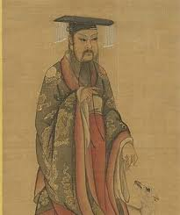
Homework Menu
Please select AT LEAST one activity from the list to do as your home learning this half term. They will link into our learning at school.
- Conduct your own research into one of the Chinese dynasties from the following list; Xia Dynasty, Shang Dynasty, Qin Dynasty and the Han Dynasty. Create a booklet, factfile, poster or powerpoint on your findings.
- Look into Oracle Bones and what messages were written on them. Can you make one of your own? What message would you put on yours?
- Why are dragons so important in Chinese culture? Design or create your own piece of artwork with a Chinese Dragon theme.
- The Shang Dynasty had many famous Kings and Queens. Find out about Fu Hao and why she was so important?
- China is a country rich in culture and mystery. What can you find out about modern day China? It’s food, important celebrations, it’s people and significant places etc.
- The Shang people loved making jewellery from Jade and weapons from Bronze. Design and make your own piece of jewellery or shield suitable for someone in the Shang era.
- Chinese writing is very different from our alphabet. Try creating a birthday or thank you card and write your message using ancient Chinese writing.
- The Chinese New Year features a different animal for each year of the Chinese Zodiac. Find out what animal represents the year you were born. What does it mean?

Note to support: This is intended to be a fun project to do at home. Please pick at least one activity to do but feel free to do as many as you like. Homework to be handed in on Wednesday 3nd December 2025!

