Acorn Class Home Learning Menu – Summer Term 2026
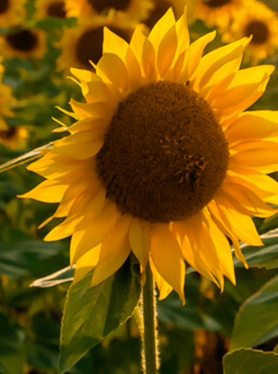

Summer 1 – Sunshine and Sunflowers
Summer 2 – Big Wide World

Please select AT LEAST one activity from the following activities to do as your home learning this half term.
Projects to be handed in on Monday 13th July 2026
Outcome morning will be on Friday 17th July at 8.30am where you will be able to come and view the children’s home learning projects.

Sunshine and Sunflowers:
Go for a bug hunt around an outside space and record all of the bugs that you find.
Find out about, and make a poster displaying, the life cycle of a frog.
Draw or paint a picture of what your dream garden would look like.
Make a repeating pattern out of nature objects such as leaves and seashells and take a photo or draw a replica.
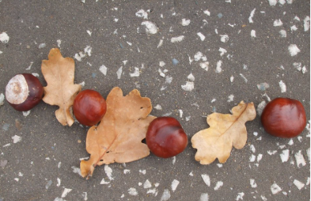
Big Wide World:
Write about places you have visited on holiday or have family living, and write about what country they are in.
Draw a picture of an animal from a different country.
If you have family or friends in a different country, interview them about differences where they live – for example language, food and weather.
Make a picture combining different shapes such as squares, triangles and rectangles.
