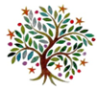
Spring 1
Year 1 & 2
Dear Parents and carers,
Welcome back for the second part of our Autumn Term; here is an idea of what we will be learning in Year 1 and 2 in our new topic: ‘London’s Burning. London’s Burning. Who was to blame?’
What will we be learning?
We have lots of fun learning coming up this half-term.

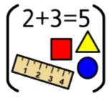
Maths:
- Addition and Subtraction
- Multiplication and division (Yr2)
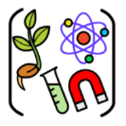
- Place Value

Science: We will be investigating how materials change and how the properties allow materials to be changed.


English: Year 1/2MB and 1/2H – Grammarsaurus – features of sentences
Yrs 1 & 2 – Using texts about historical events to write diary entries
Year 2 - Writing instructions and preforming and creating shape poems
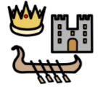
History: We will be learning about The Great Fire of London: Where it started? How it started?
We will also be discussing who we think was to blame. Our theme will start with an
interactive workshop.
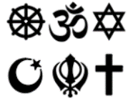
RE: We will be focusing on a theme that encompasses a wide variety of religious and non-religious worldviews. Our key question is, ‘What is most important for different people?’ We are going to look at what is important to myself and others as well as ‘Why is God important to some people?’
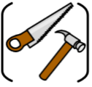
DT: Structures - We will be designing and making 3D models of houses.

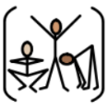
PE: Year 1/2MB PE days will be Tuesday and Thursday.
Year 1/2CH PE days will be Monday and Thursday
Year 2 PE days will be Monday and Friday.
We will be working on Gymnastic skills and ball skills.
Computing: We will be learning about our online relationships and how to stay safe. We will also be exploring Purple Mash and coding.

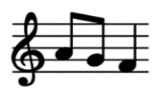
Music: We will be working on creating compositions including creating our own versions of familiar songs.

Parent Drop-ins

Subject | Date & Time | Activity
Reading | 13.1.26  2:45 – 3:15pm | Phonic/spelling activities and reading session.
Theme: Design Technology | Date to be confirmed | We would like to share the work we have been doing this half term – We will have been rebuilding Pudding Lane in London after the Great Fire

