
Spring
Year 5 & 6
Dear Parents and carers,
Welcome back for the Spring term; here is an idea of what we will be learning in Year 5 and 6 in our new topic: ‘Do all actions have consequences?’
What will we be learning?
We have lots of fun learning coming up this half-term.
Maths:
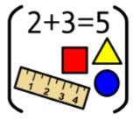
- converting measure
- Fractions, decimals and percentages


Science: Forces and mechanisms

English: In English we will be exploring the texts ‘Goodnight Mr Tom’ by Michelle Magorian and ‘My Secret War Diary’ by Flossie Albright. These texts will support our learning in history. We will be focusing on writing formal letters, dialogue in narrative and also instructions
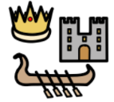
History: We will explore the impact World War Two had on the people of Britain, and more specifically, Coventry.
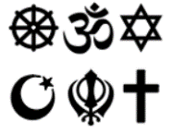
RE: We will be exploring the question ‘How might your worldview impact on the way you understand death and beyond?’

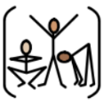
DT: We are going to be designing, making and evaluating a bridge – learning different techniques to create a strong and sturdy structure.


PE: We will be practising our skills in hockey and developing our skills in gymnastics. Year 5/6 T have PE on Thursday and Friday. Year 5/6P have PE on Wednesday and
Friday. Year 5/6WP have PE on Wednesday and Thursday.

Computing: Year # will become netiquette experts whilst Year # will ensure they know all about being respectful of digital rights and responsibilities
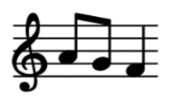
Music: We will be looking at the composition of music, while also practicing the songs for Young Voices.

