Makaton signs for this week (08.12.2025)
winter

Video link
https://www.youtube.com/watch?v=eXAxmCY5eRM
Christmas
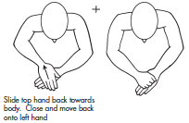
Video link
https://www.youtube.com/watch?v=pbbtBxysJ4c

