Makaton signs for this week (01.12.2025)
spider
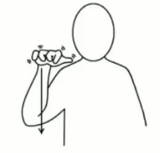

Video link
https://www.youtube.com/watch?v=nBGCKdVsoa4
bird
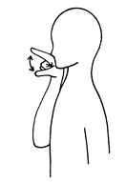
Video link
https://www.youtube.com/watch?v=lUwjtHPx1x0

