Makaton signs for this week (15.12.2025)
Stop

https://www.youtube.com/watch?v=QZJuQ8LHJS4
Sorry
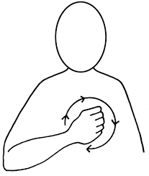
Video link
https://www.youtube.com/watch?v=h3_x8uwSXVI

