Makaton signs for this week (24.11.2025)
Please
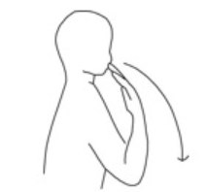
Bring fingertips to chin then bring arm down in a long arch

Video link
https://www.youtube.com/watch?v=LiNxLZGbEYM
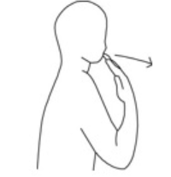
Thank You
Tap fingertips on chin then pull hand forward slightly

Video link
https://www.youtube.com/watch?v=x22Ye0uiTMY

