Makaton signs for this week (10.11.2025)
to paint
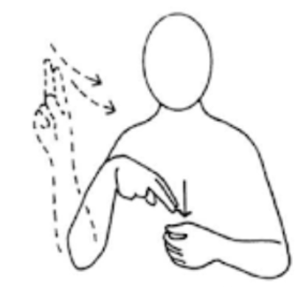

Video link
https://www.youtube.com/watch?v=H56FocjfR7g
colour
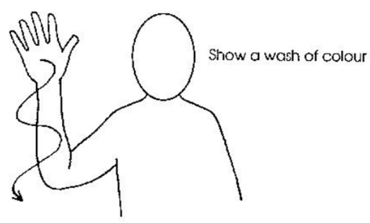
Video link
No video

