Makaton Signs for this week (06.10.2025)
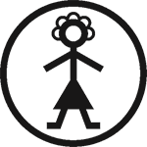
Mummy/mum/mother
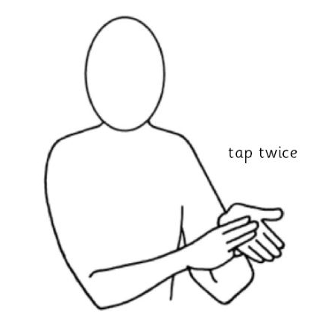
https://www.youtube.com/watch?v=3PlCbb-0OLc
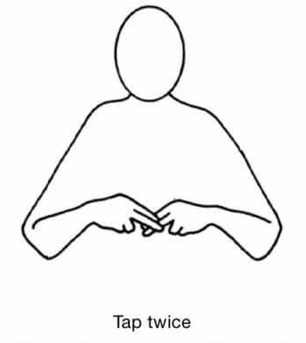
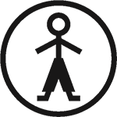
Daddy/Dad/Father

Video link
(same as above)

